<https://www.youtube.com/watch?v=Qc5IyLW_hns&list=PLblh5JKOoLUICTaGLRoHQDuF_7q2GfuJF&index=57>

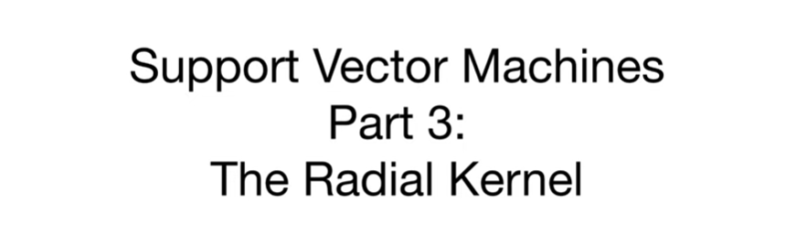

Today we're gonna talk about support vector machines part 3 the radial kernel.

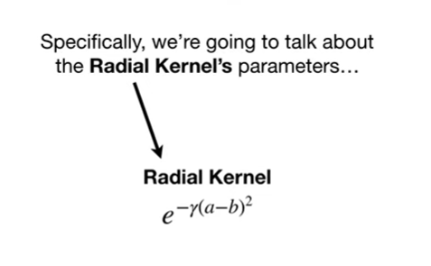

Specifically we're going to talk about the radial kernels parameters

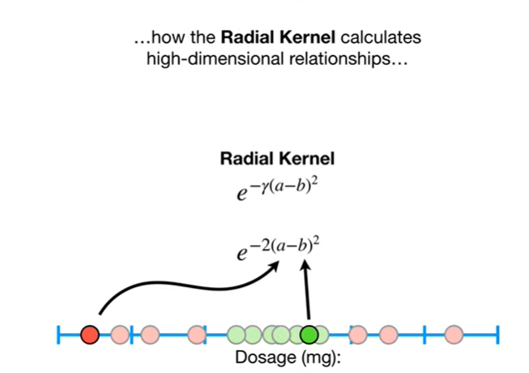

how the radio kernel calculates high dimensional relationships

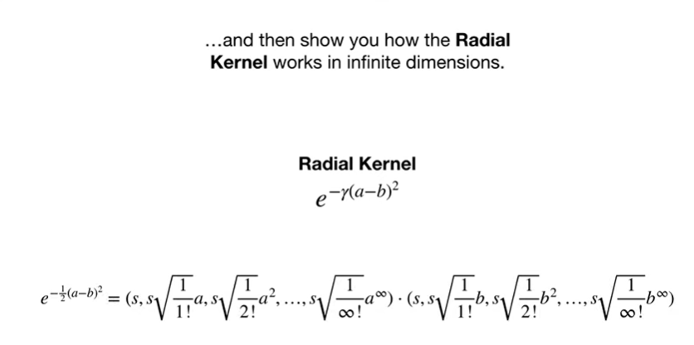

and then show you how the radial kernel works in infinite dimensions.



Note : this stack quest assumes that you are already familiar with support vector machines and the polynomial kernel if not check out the quests.

Tthe links are in the description below.



In the stack quest on support vector machines, we had a training data set based on drug dosages measured in a bunch of patients.



The red dots represented patients that were not cured



and the green dots represented patients that were cured.

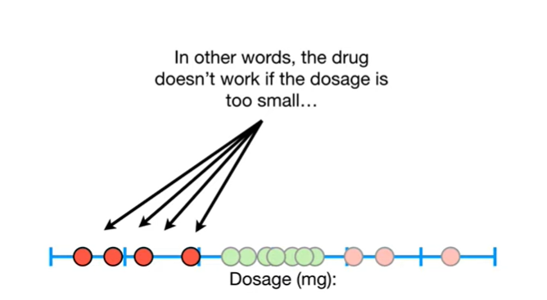

In other words, the drug doesn't work if the dosage is too small

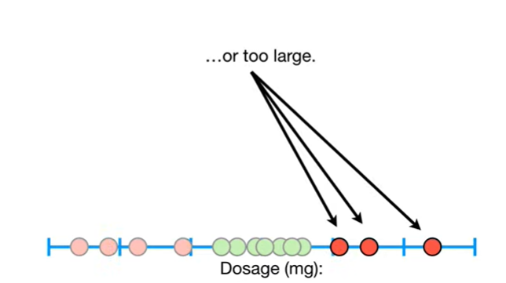

or too large.

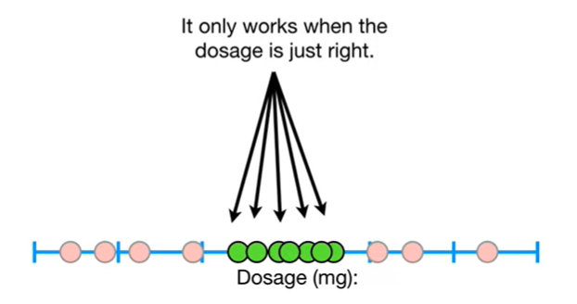

It only works when the dosage is just right.







Because this training data set had so much overlap we were unable to find a satisfying support vector classifier to separate the patients that were cured from the patients that were not cured.

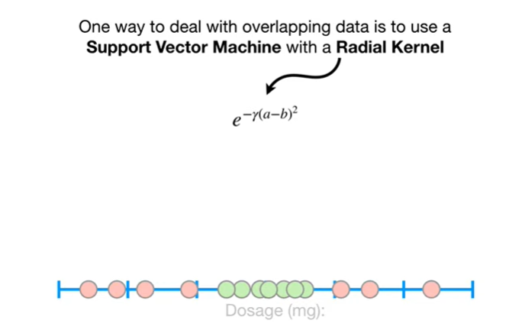

One way to deal with overlapping data is to use a support vector machine with a radial kernel

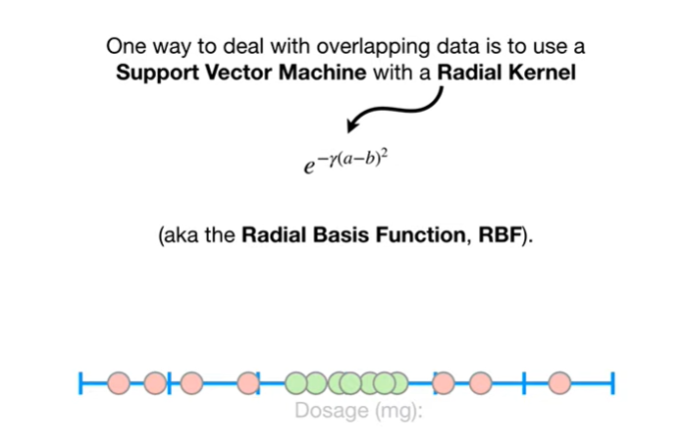

aka the radial basis function, RBF.

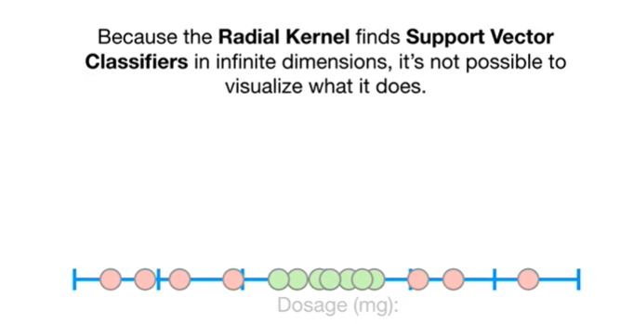

Because the radio Colonel find support vector classifier in infinite dimensions, it's not possible to visualize what it does.

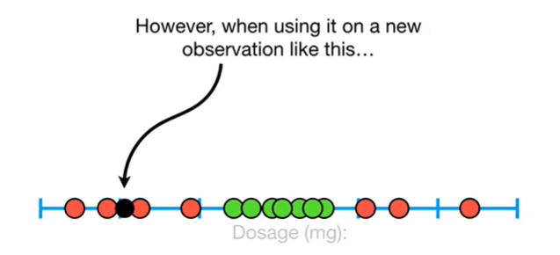

However, when using it on a new observation like this

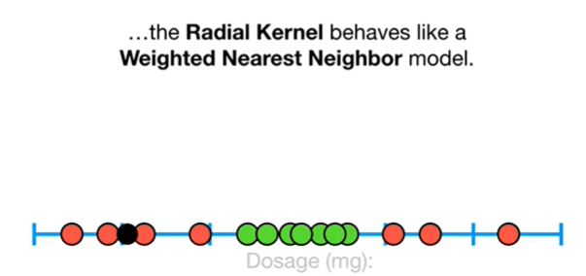

the radio kernel behaves like a weighted nearest neighbor model.

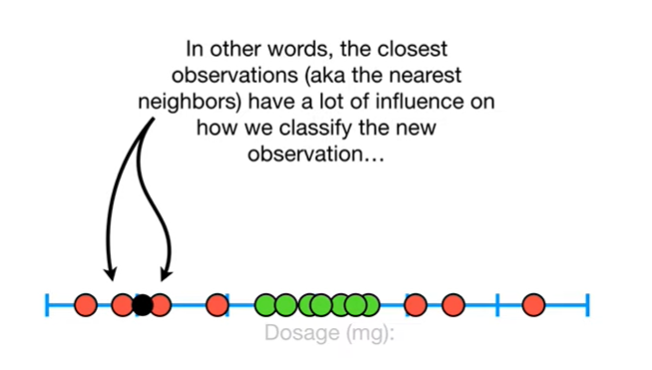

In other words, the closest observations (aka the nearest neighbors) have a lot of influence on how we classify the new observation

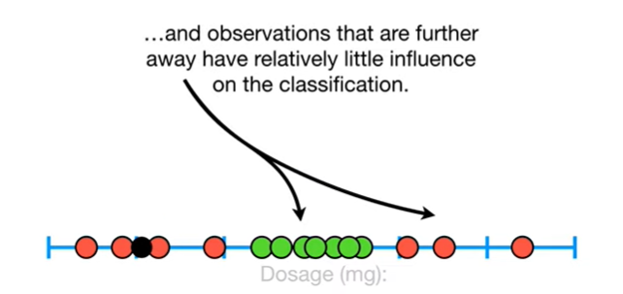

and the observations that are further away have relatively little influence on the classification.

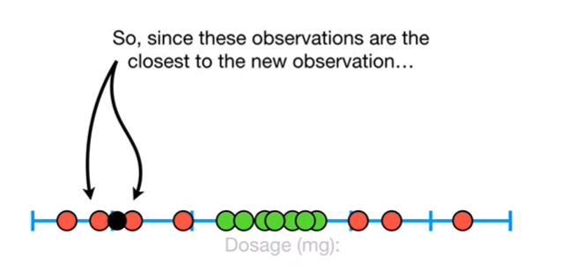

So, since these observations are the closest to the new observation

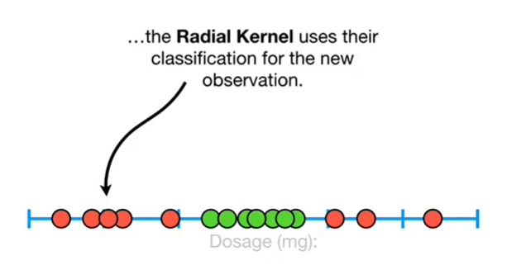

the radio kernel uses their classification for the new observation.

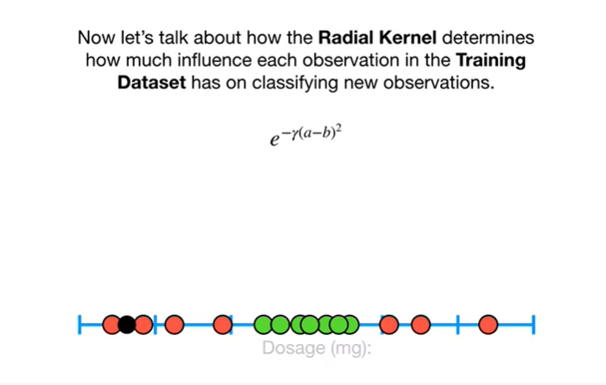

Now let's talk about how the radio Colonel determines how much influence each observation in the training dataset has on classifying new observations.

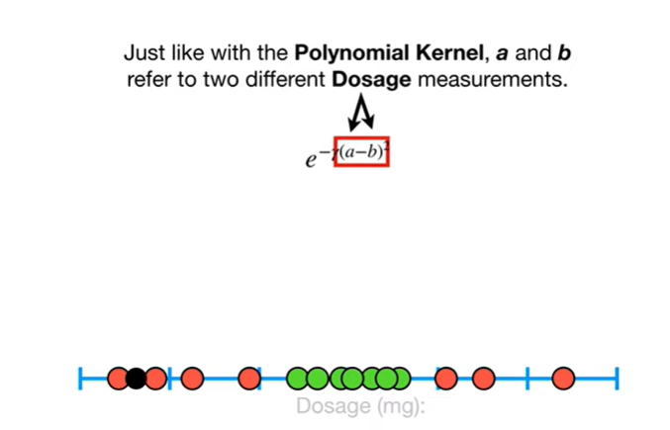

Just like with the polynomial kernel, a and b refer to two different dosage measurements

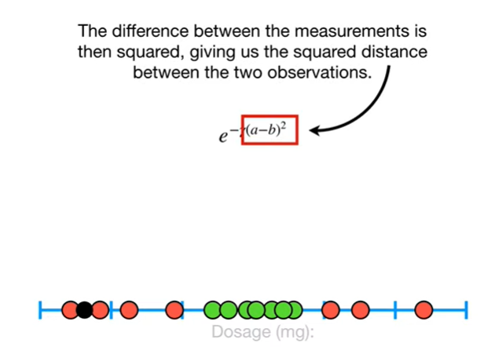

The difference between the measurements is then squared giving us the squared, distance between the two observations.

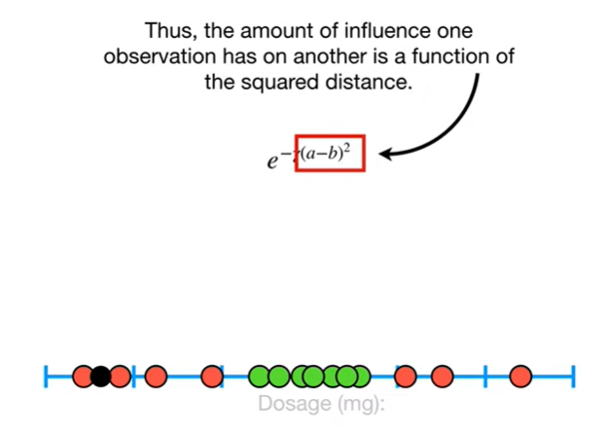

Thus the amount of influence one observation has on another is a function of the squared distance.

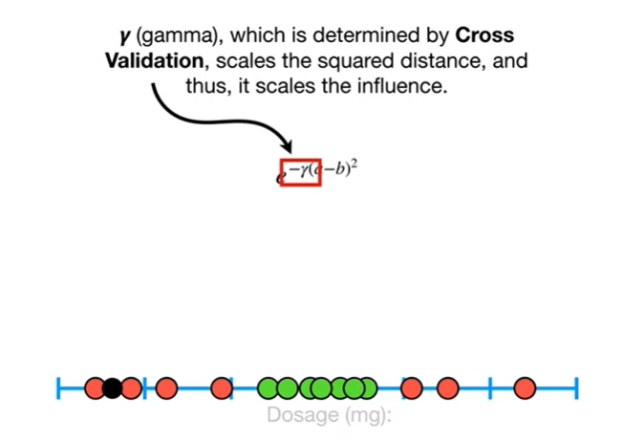

Gamma, which is determined by cross-validation, scales the squared distance, and thus, it scales the influence.

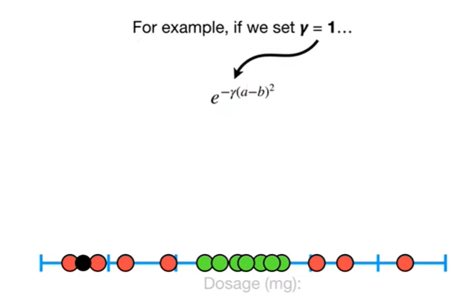

For example, if we set gamma equal to one

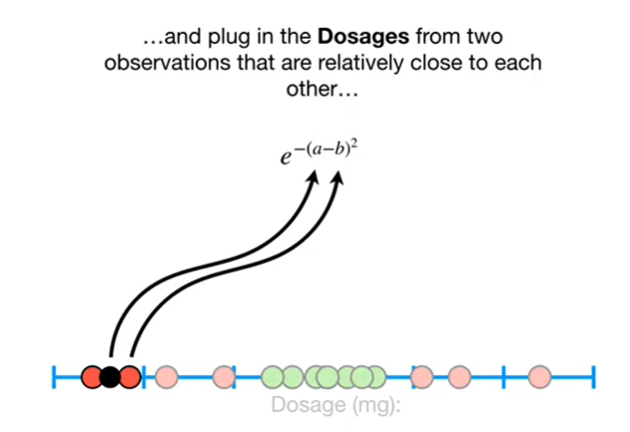

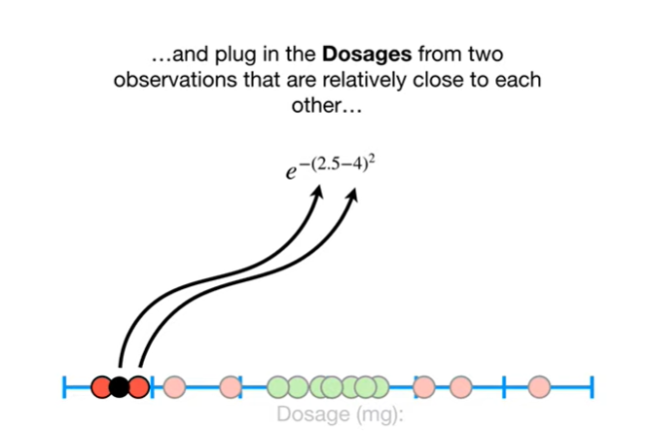

plug in the dosages from two observations that are relatively close to each other

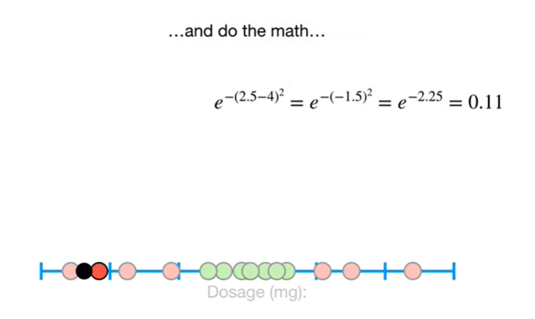

and do the math

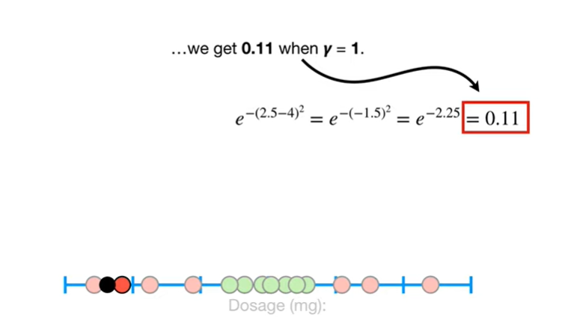

we get 0.11 when gamma equals 1.

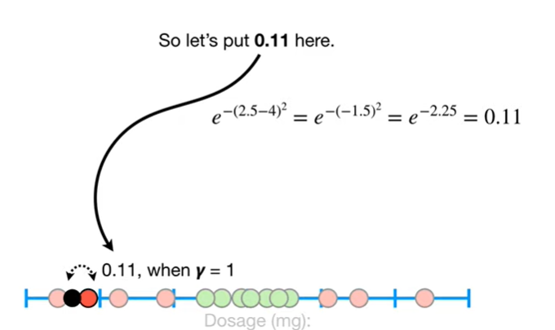

So let's put 0.11 here.

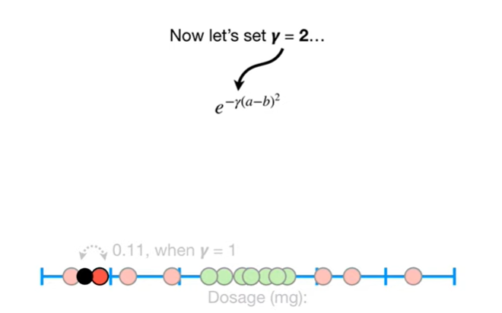

Now let's set gamma equal to two

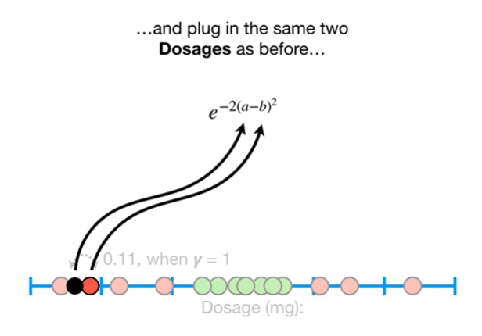

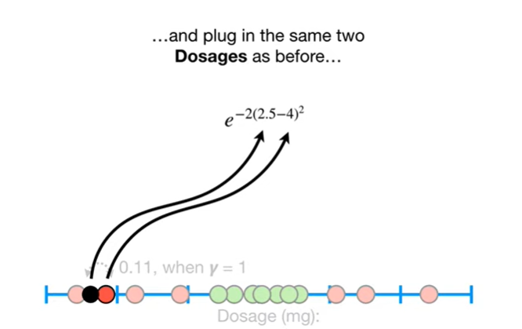

and plug in the same two dosages as before

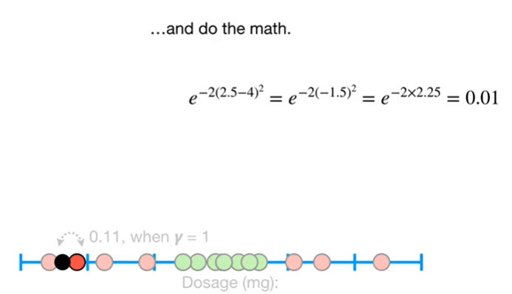

and do the math

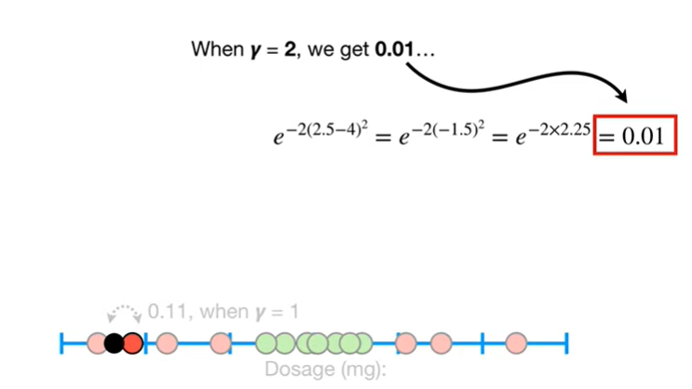

when gamma equals 2, we get 0.01

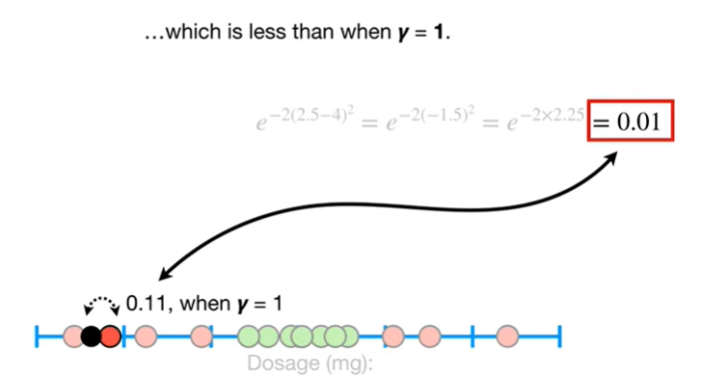

which is less than when gamma equals 1.

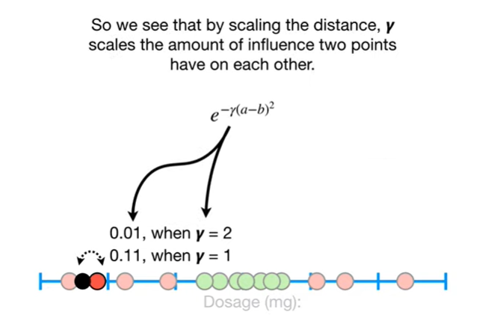

So we see that by scaling the distance, gamma scales the amount of influence two points have on each other.

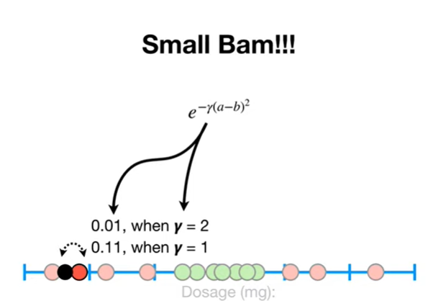

Small BAM !!!

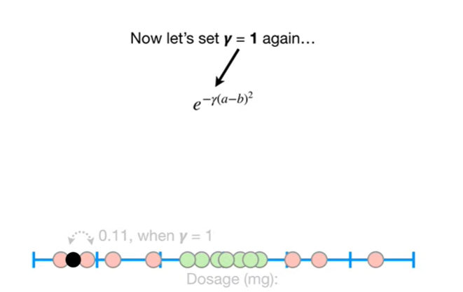

Now let's at gamma equal to 1 again

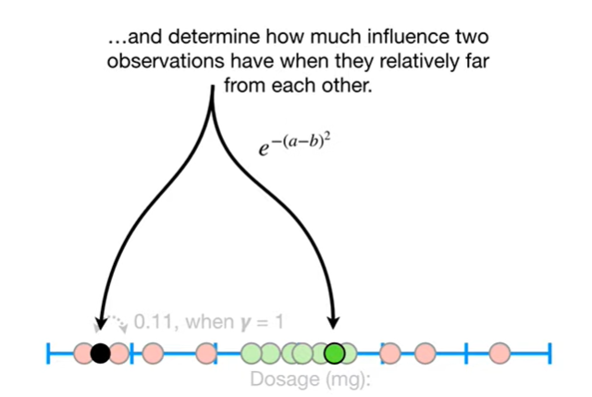

and determine how much influence two observations have when they are relatively far from each other

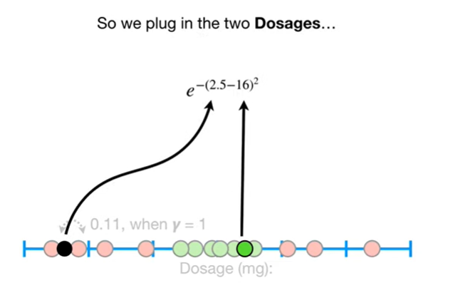

so we plug in the two dosages

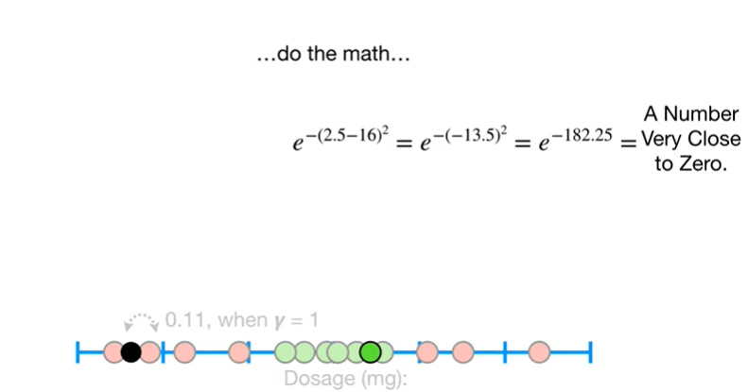

do the math

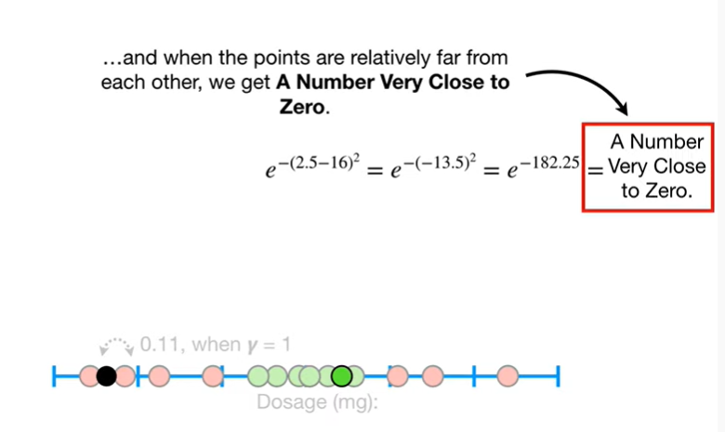

and when the points are relatively far from each other, we get a number very close to zero.

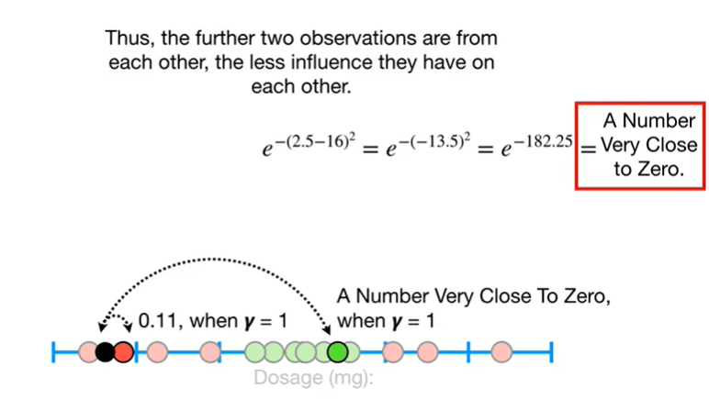

Thus, the further two observations are from each other the less influence they have on each other.

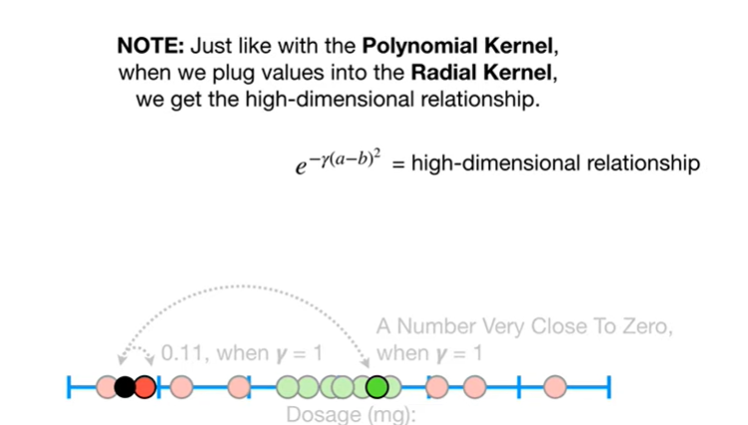

Note : just like with the polynomial kernel when we plug values into the radial kernel we get the high-dimensional relationship.

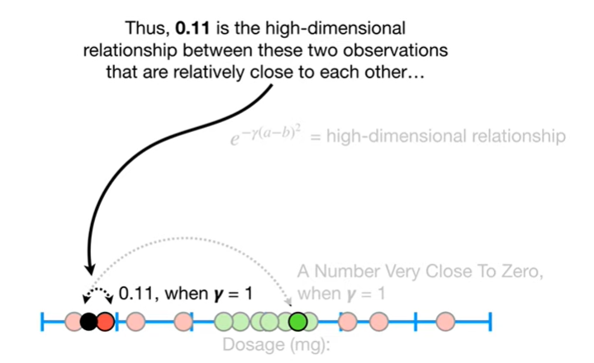

Thus 0.11 is the high dimensional relationship between these two observations that are relatively close to each other

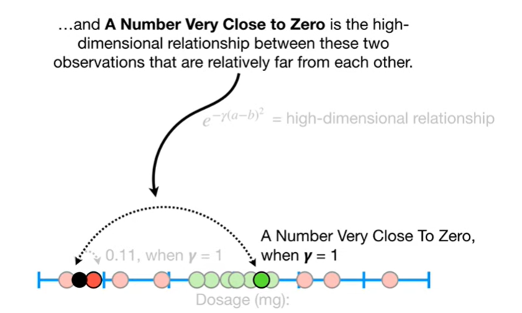

and a number very close to zero is the high dimensional relationship between these two observations that are relatively far from each other.

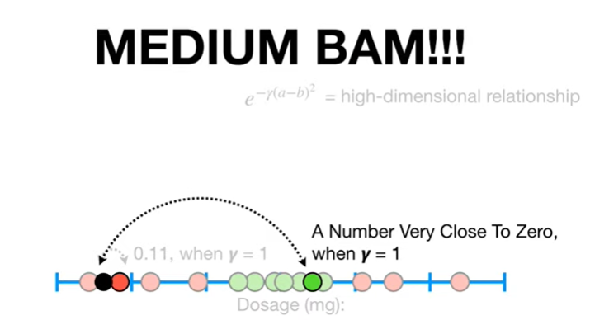

Medium Bam !!!

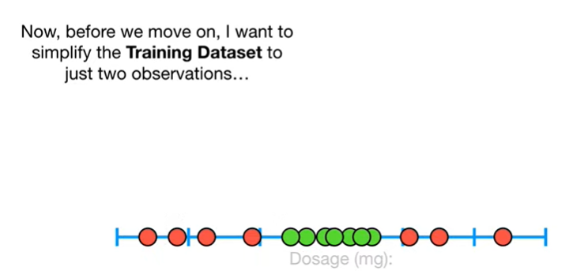

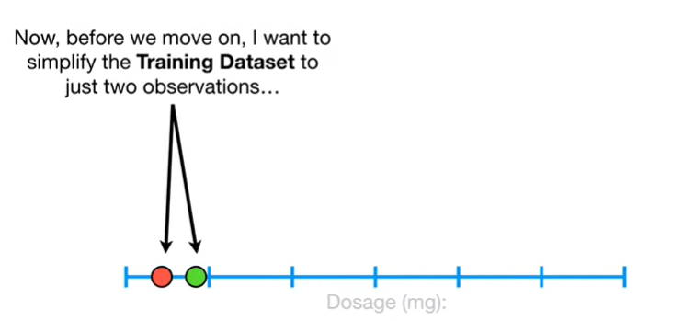

Now before we move on I want to simplify the training data set to just two observations

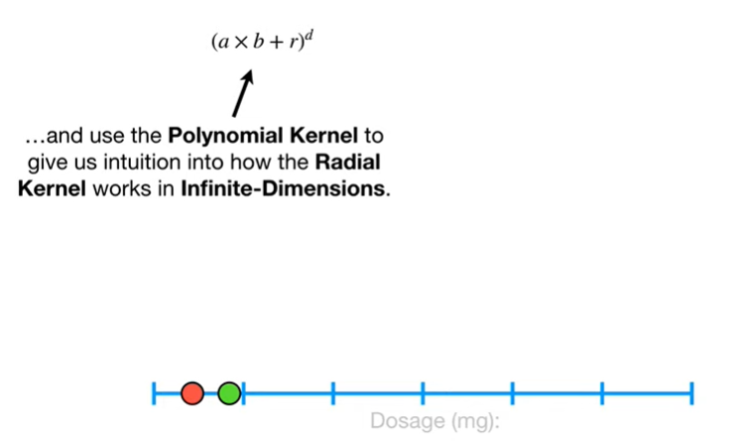

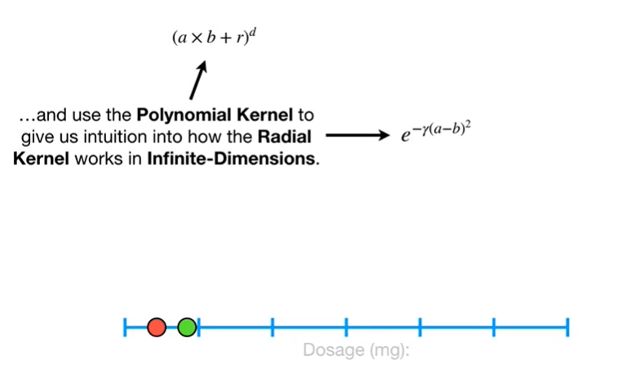

and use the polynomial kernel to give us intuition into how the radio kernel works in infinite dimensions

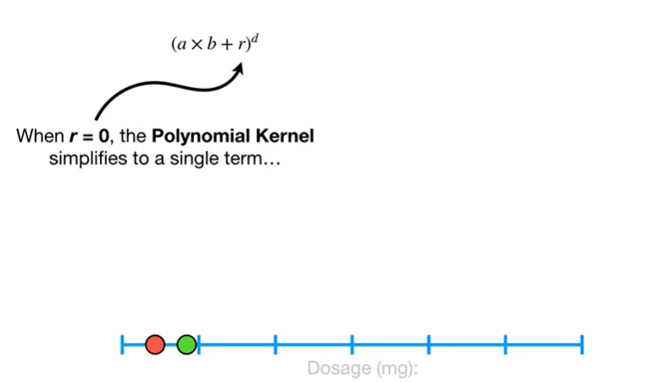

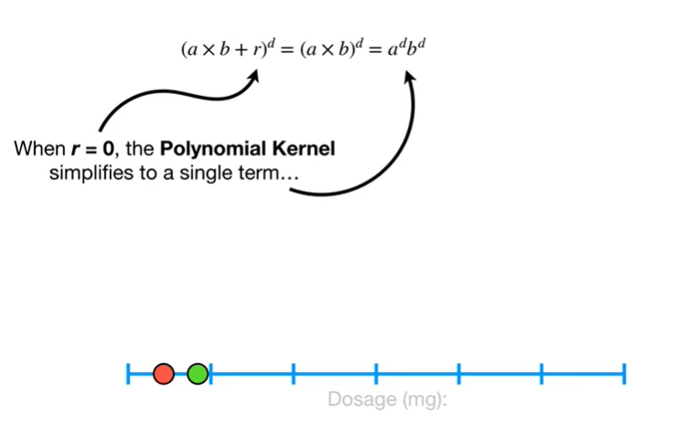

When r equals zero, the polynomial kernel simplifies to a single term

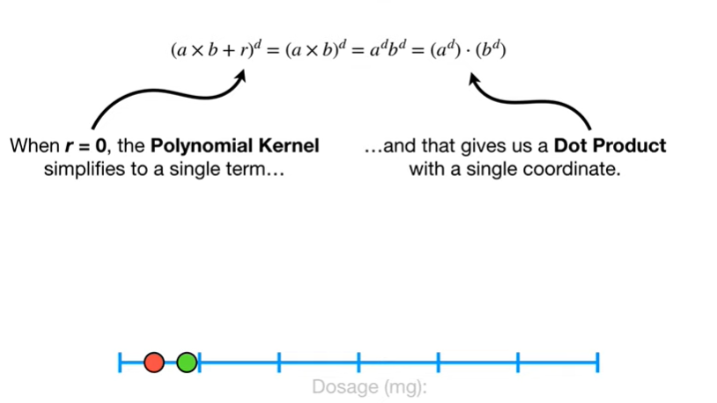

and that gives us a dot product with a single coordinate.

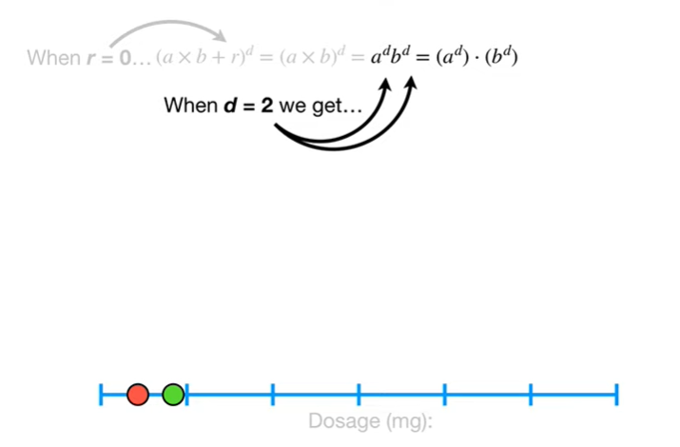

When d equals 2 we get

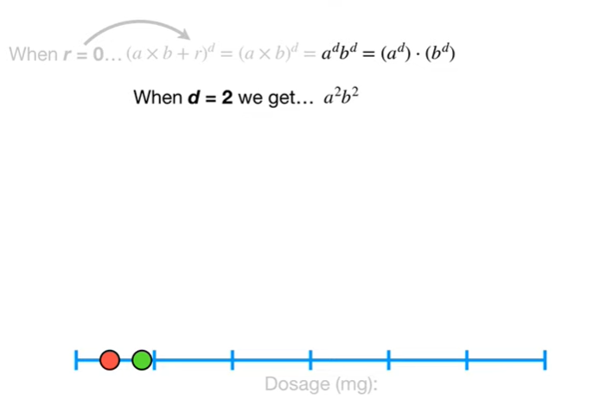

a squared times b squared



which is equal to the dot product of a squared and b squared.

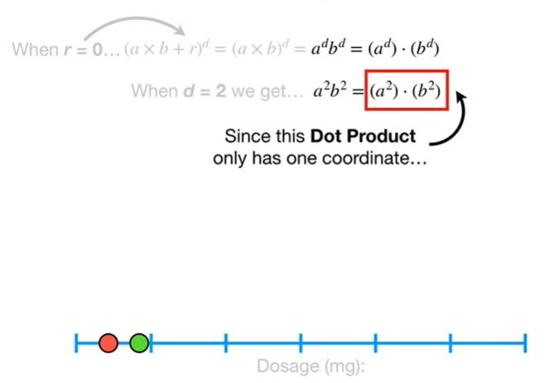

Since this dot product only has one coordinate

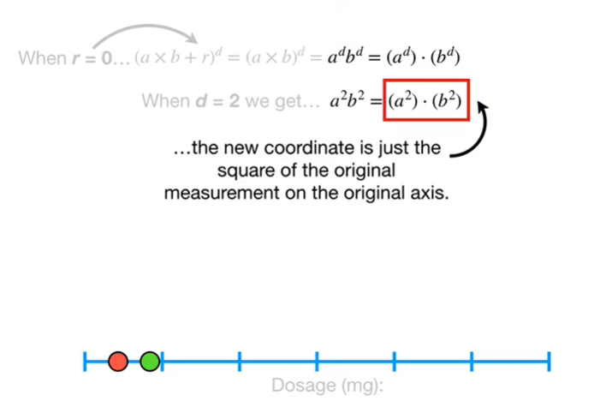

the new coordinate is just the square of the original measurement on the original axis.

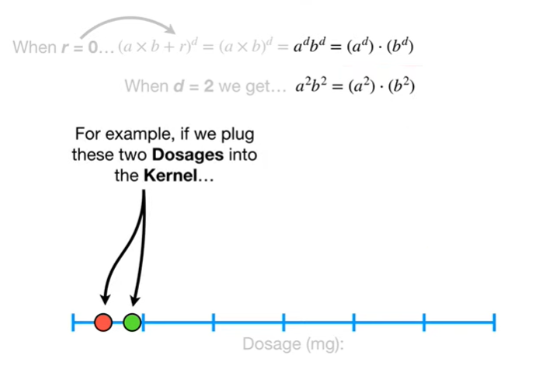

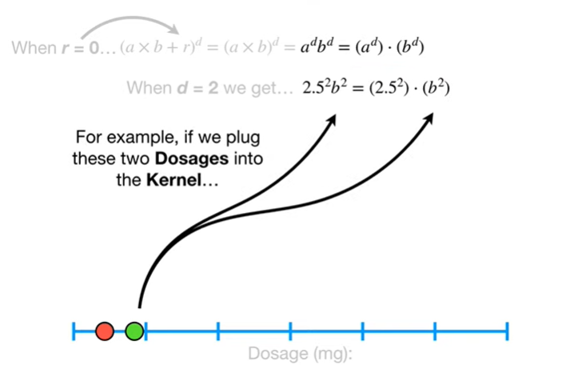

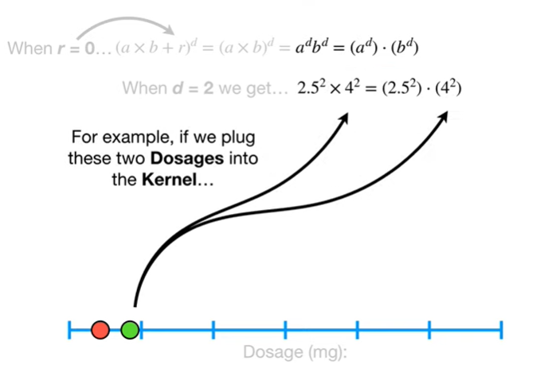

For example if we plug these two dosages into the kernel



we get this dot product

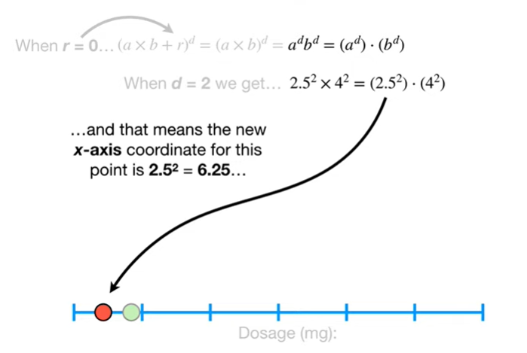

and that means the new XS coordinate for this point is two point five squared which equals six point two five

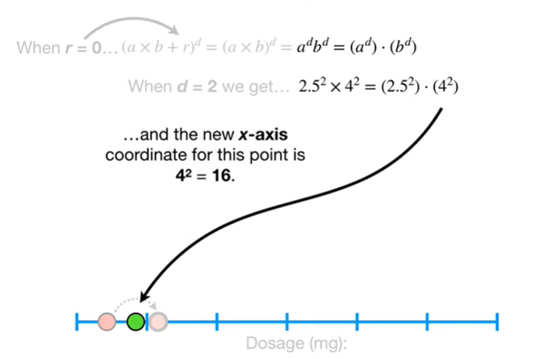

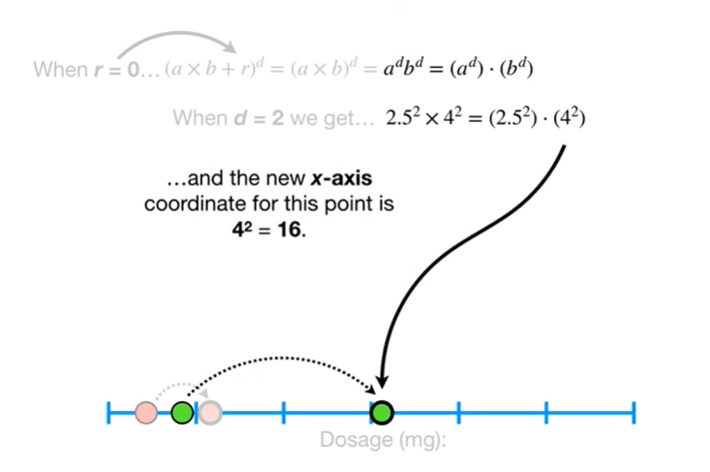

and the new x-axis coordinate for this point is four squared which equals 16.

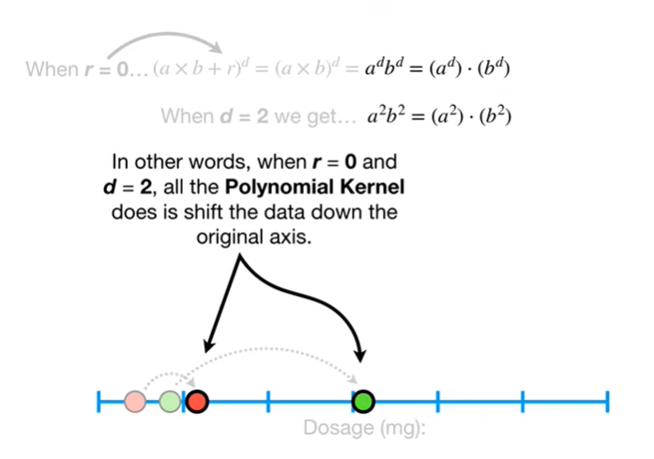

In other words, when r equals zero and d equals two, all the polynomial kernel does is shift the data down the original axis.

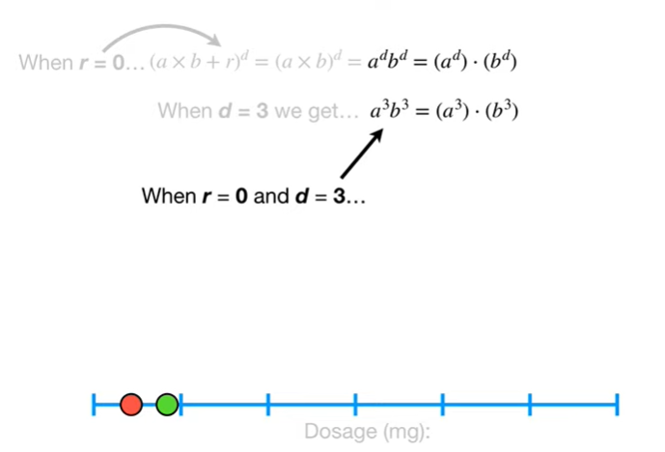

When r equals 0 and d equals 3



we still only have one coordinate in the dot product

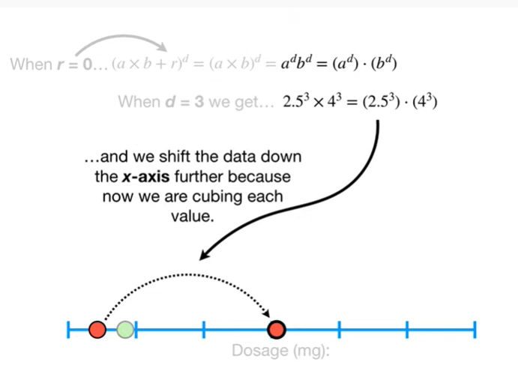

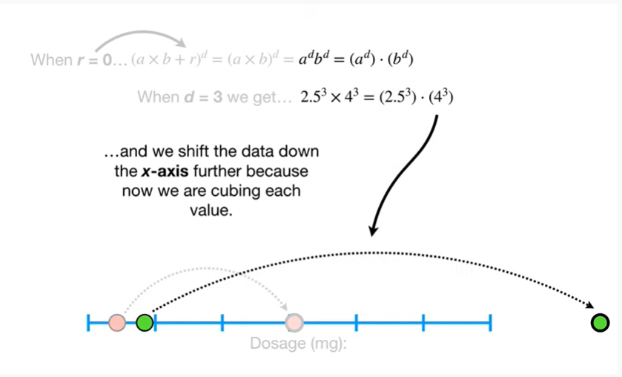

and we shift the data down the X access further because now we are cubing each value.

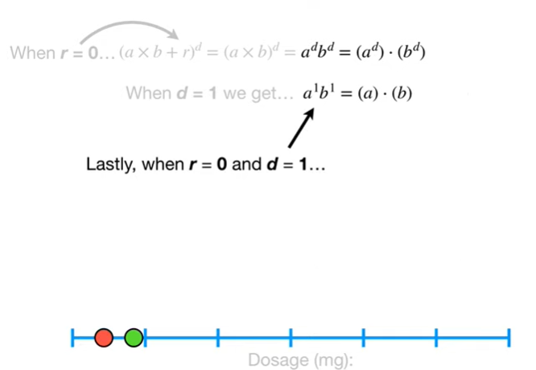

Lastly, when r equals zero and d equals one



we still only have one coordinate in the dot product

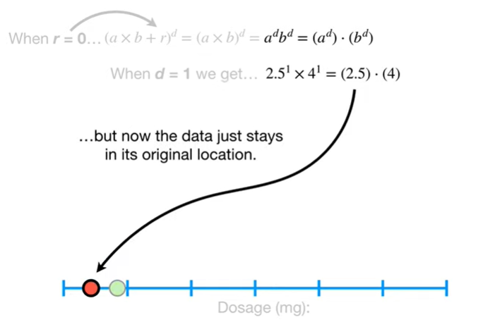

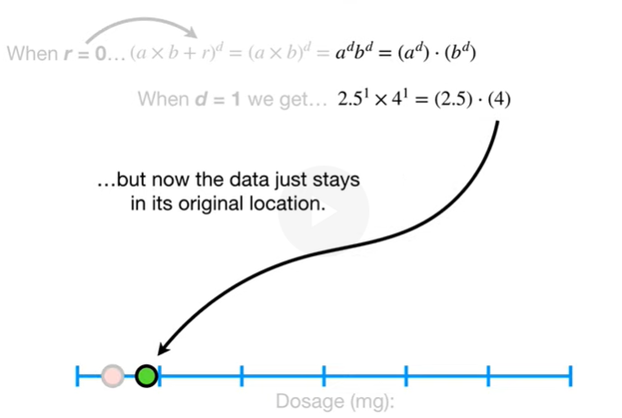

but now the data just stays in its original location.

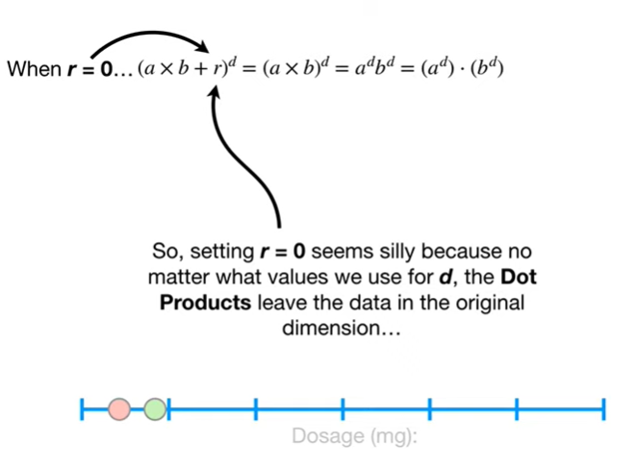

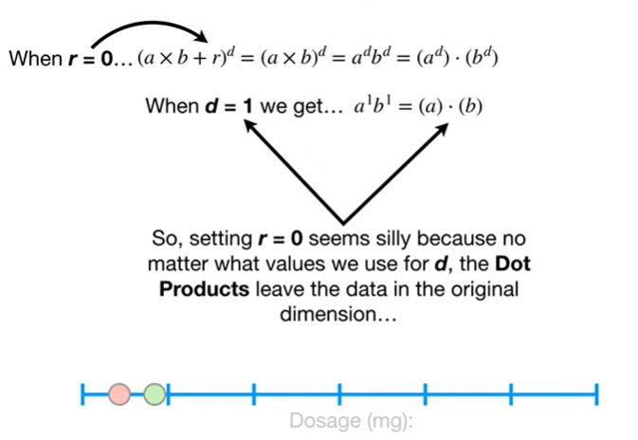

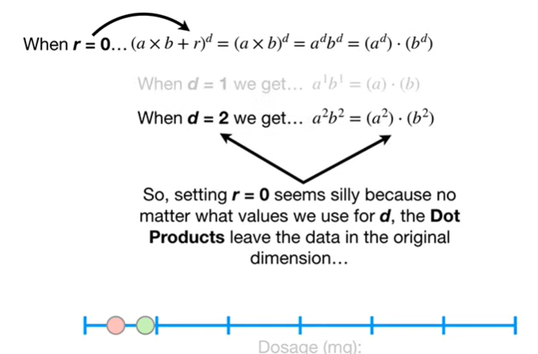



So, setting R equals zero seems silly because no matter what values we use for d, the dot products leave the data in the original dimension

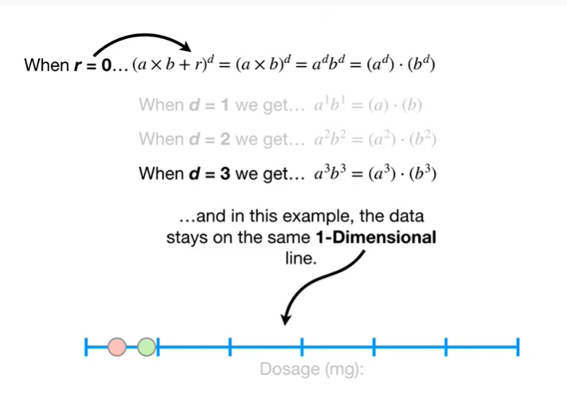

and in this example the data stays on the same one-dimensional line.

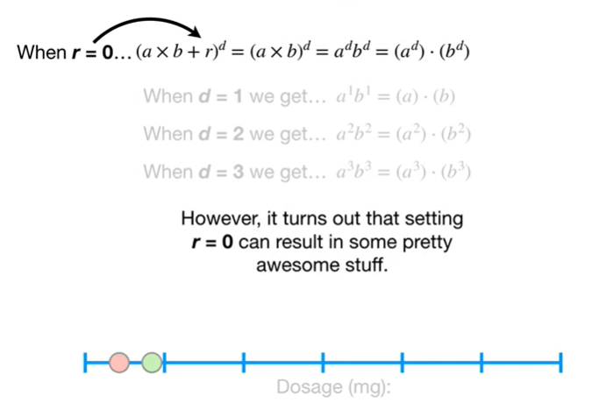

However, it turns out that setting r equals zero can result in some pretty awesome stuff.



Going back to the original training data set

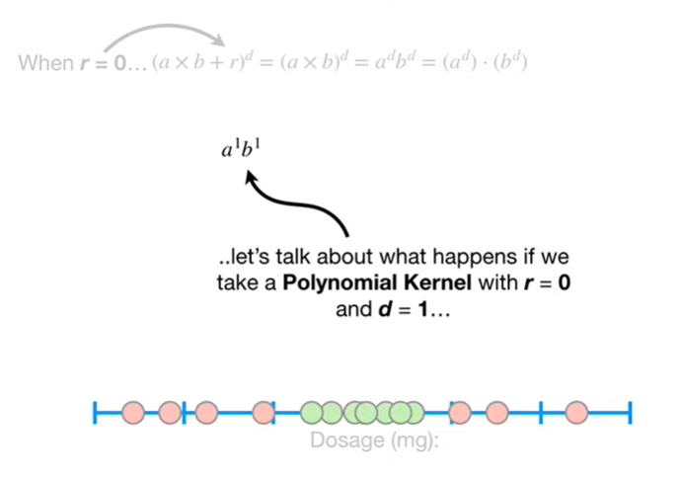

let's talk about what happens if we take a polynomial kernel with r equals 0 and d equals 1

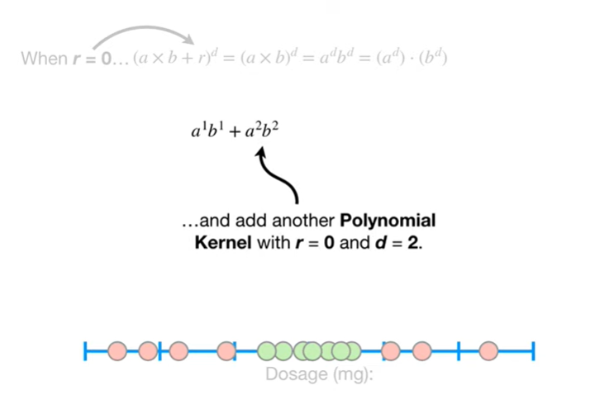

and add another polynomial kernel with r equals 0 and d equals 2.



This gives us a dot product with coordinates for two dimensions.



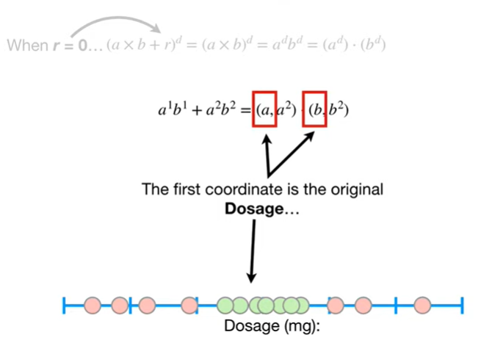

The first coordinate is the original dosage

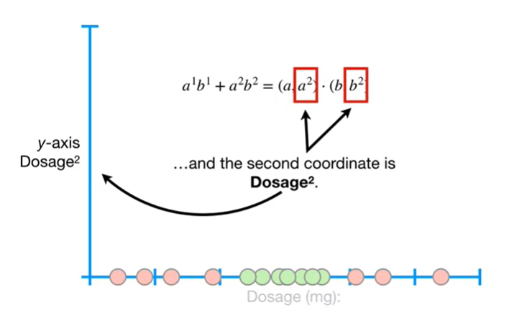

and the second coordinate is dosage squared.

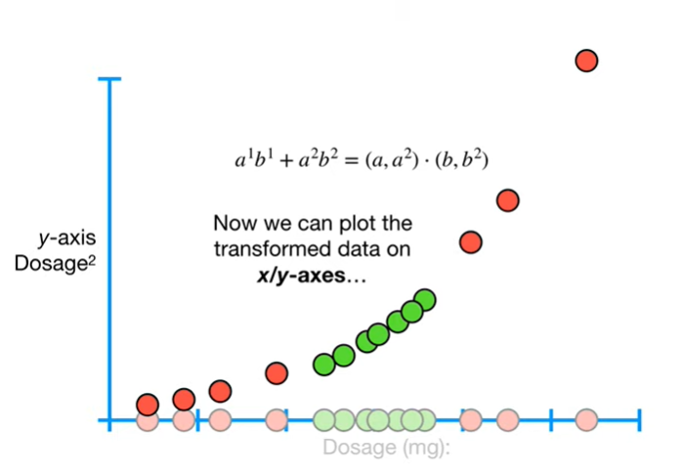

Now we can plot the transform data on X/Y axes

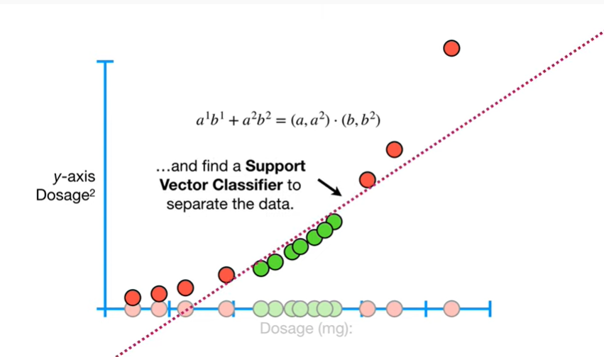

and find a support vector classifier to separate the data.

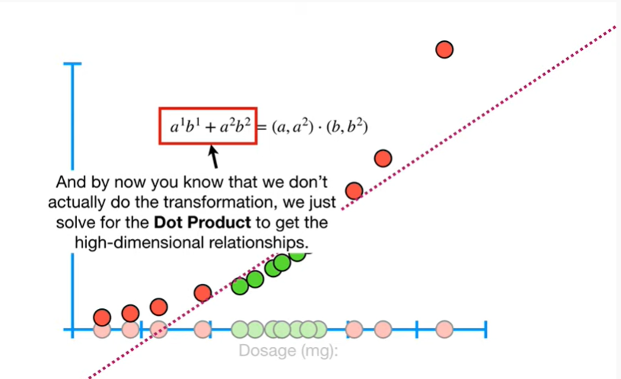

And by now you know that we don't actually do the transformation, we just solve for the dot product to get the high dimensional relationships.

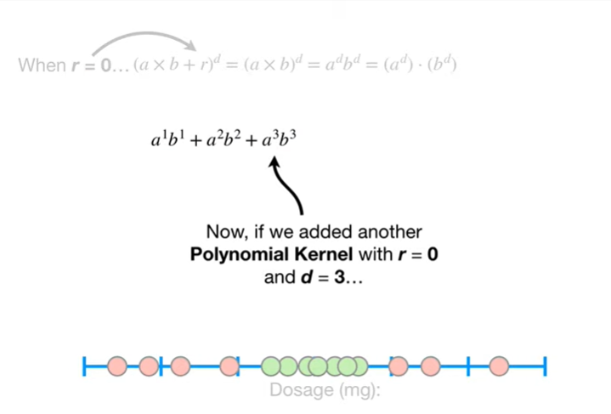

Now, if we added another polynomial kernel with r equals zero and d equals three



then the dot product has coordinates for three dimensions

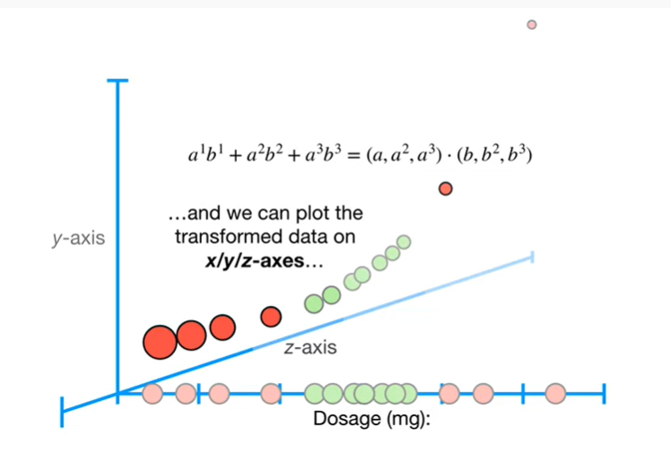

and we can plot the transform data on X/Y/Z axes

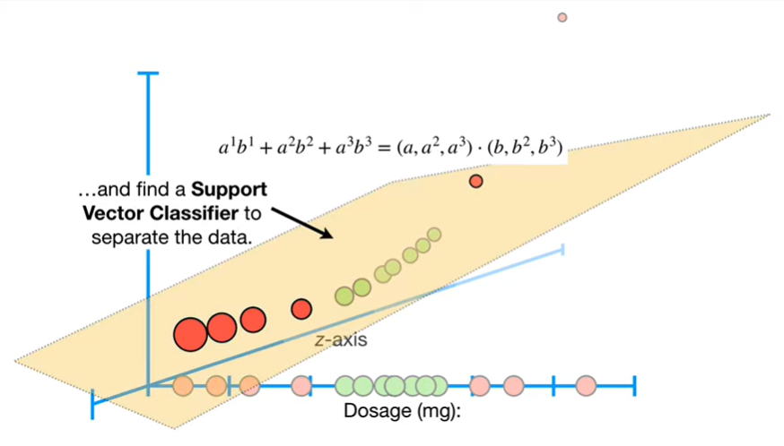

and find a support vector classifier to separate the data.

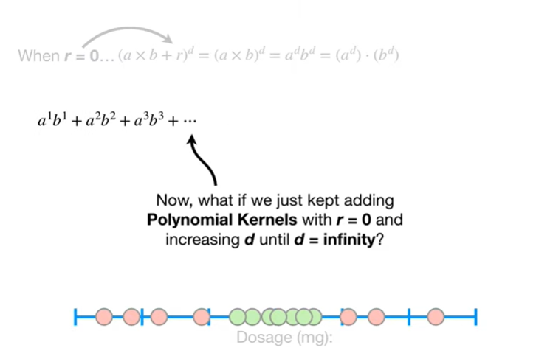

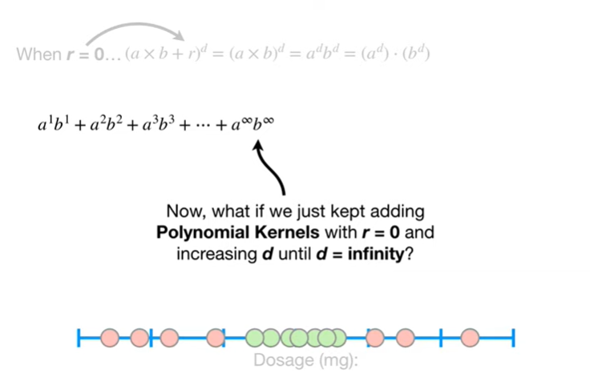

Now what if we just kept adding polynomial kernels with r equals zero and increasing d until d equals infinity ?

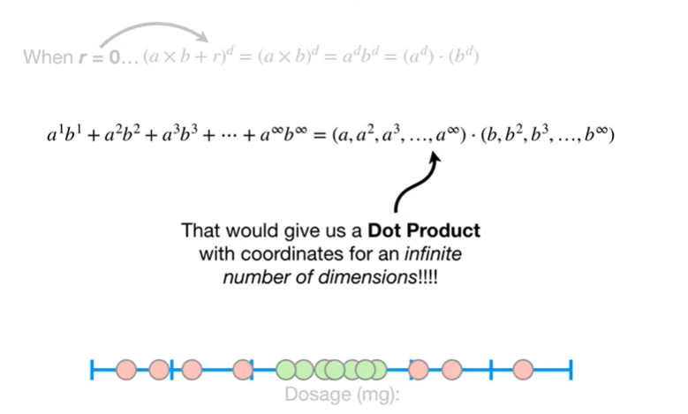

That would give us a dot product with coordinates for an infinite number of dimensions !!!



That would be awesome right ?

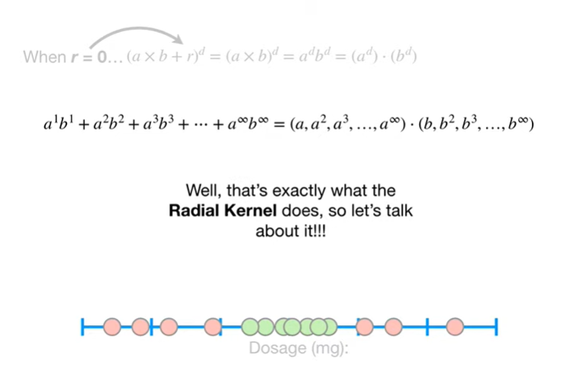

Well, that's exactly what the radio Colonel does, so let's talk about it !!!



Warning this part gets very mathy, so feel free to skip to the end if this is not your thing.



Let's start with the radial kernel

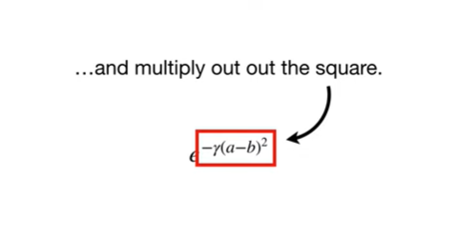

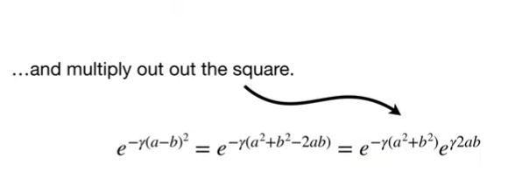

and multiply out the square.

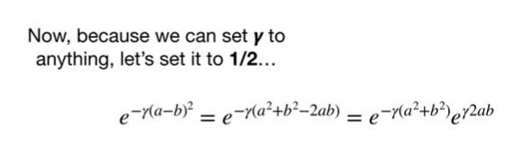

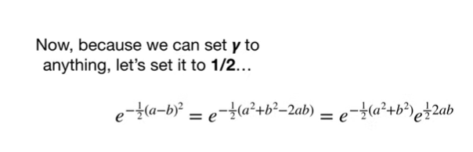

Now ,because we can set gamma equal to anything let's set it to 1/2

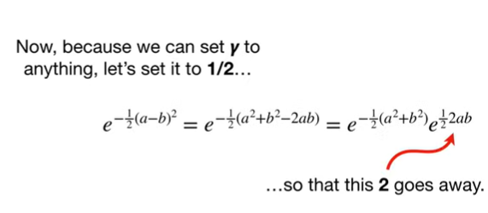

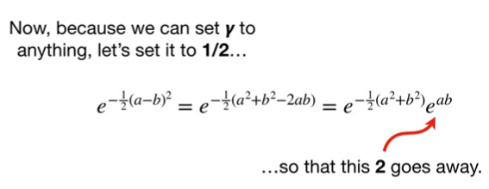

so that this 2 goes away.

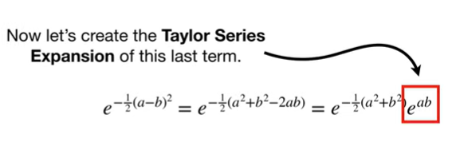

Now let's create the Taylor series expansion of this last term.

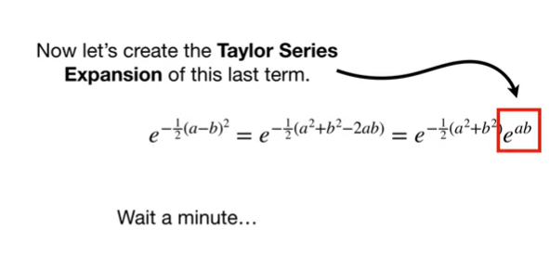

Wait a minute…

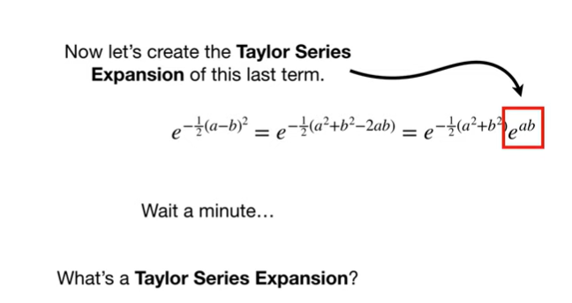

What's a Taylor series expansion ?

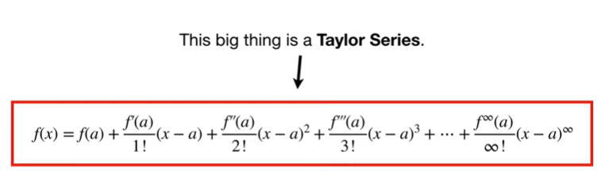

This big thing is a Taylor series.

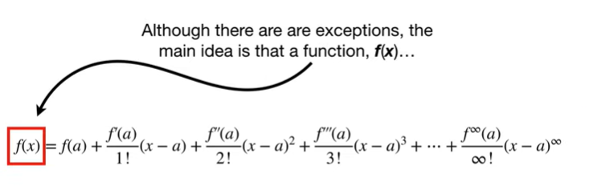

Although there are exceptions the main idea is that a function, f of X

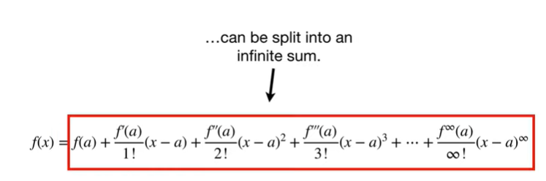

can be split into an infinite sum.

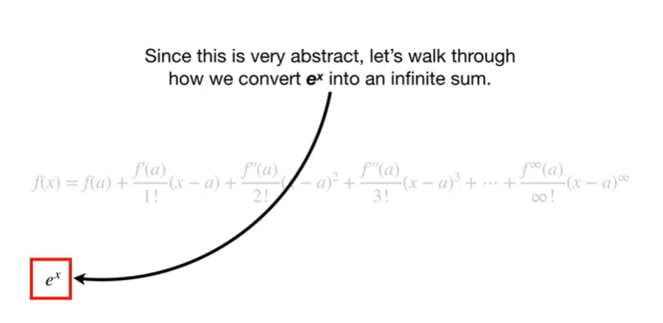

Since this is very abstract let's walk through how to convert e to the X into an infinite sum.

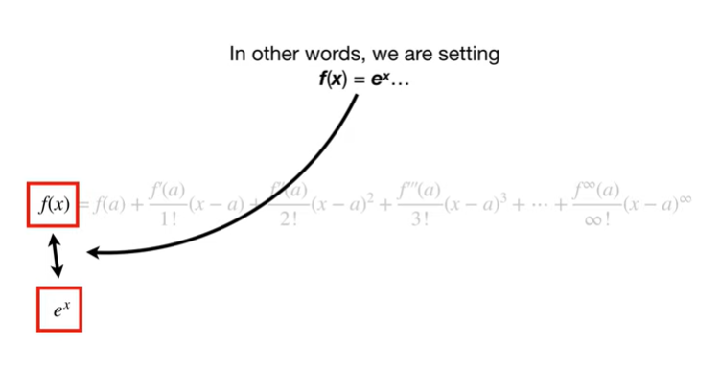

In other words we are setting f of X equal to e to the X

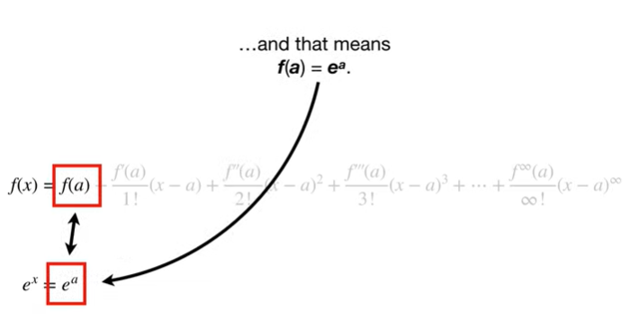

and that means F of a equals e to the a.

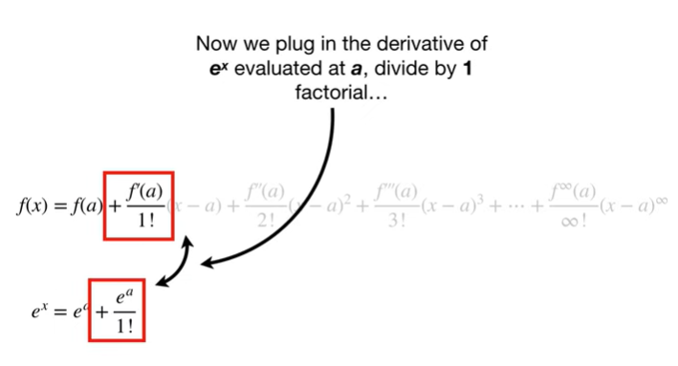

Now we plug in the derivative of e to the X evaluated at a, divided by 1 factorial

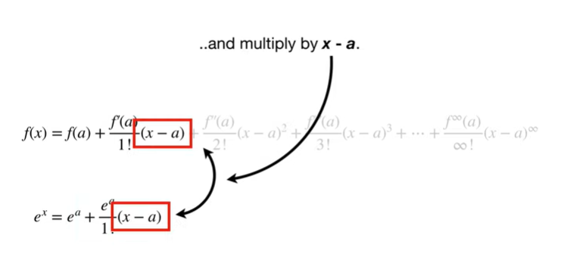

and multiplied by X minus a.

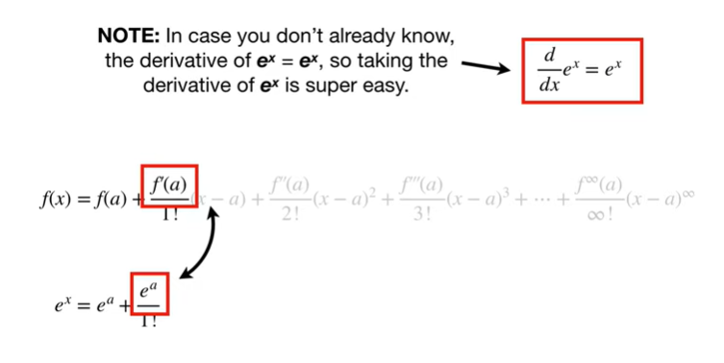

Note : in case you don't already know the derivative of e to the X equals e to the X so taking the derivative of e to the X is super easy.

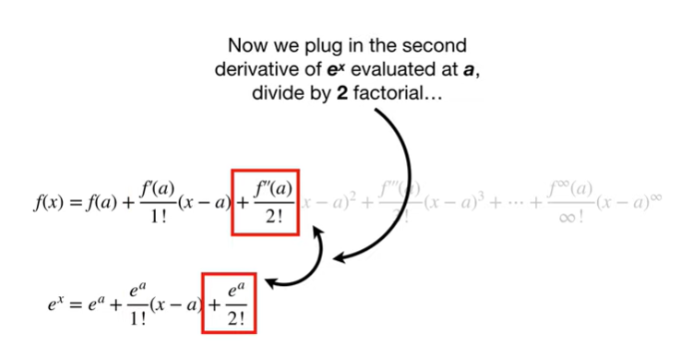

Now we plug in the second derivative of e to the X evaluated at a, divided by 2 factorial

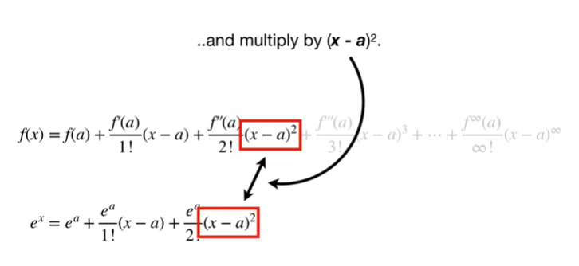

and multiplied by X minus a squared.

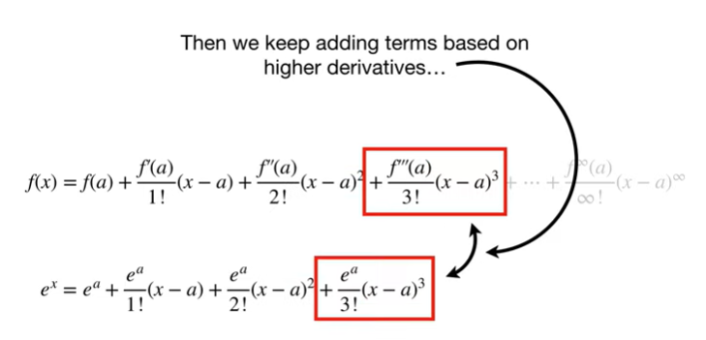

Then we keep adding terms based on higher derivatives

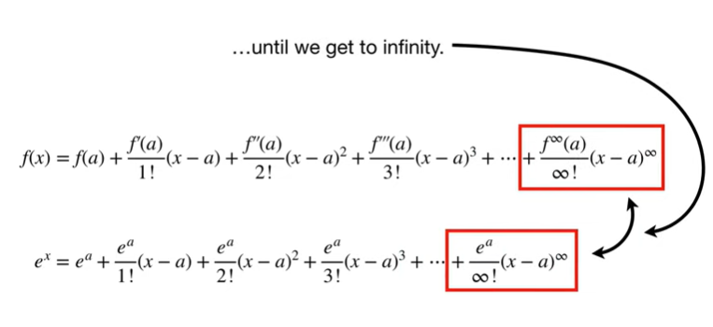

until we get to infinity.

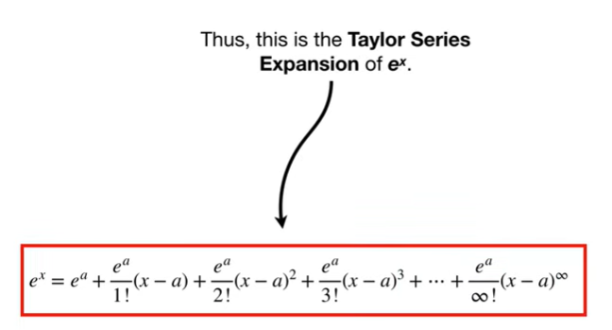

Thus, this is the Taylor series expansion of e to the X.

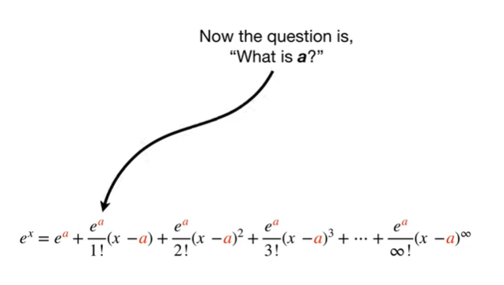

Now the question is what is a ?

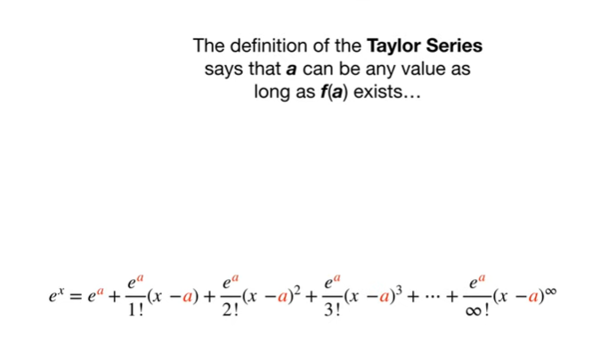

The definition of the Taylor series says that a can be any value as long as F of a exists

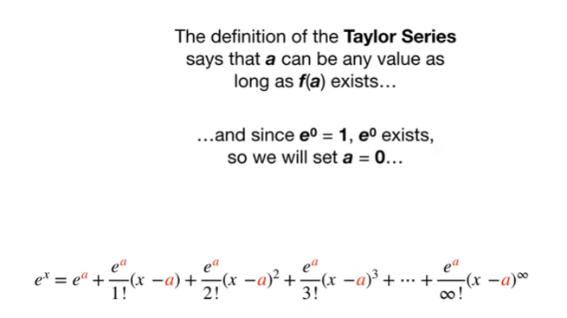

and since e to the zero equals one e to the zero exists so we will set a equal to zero

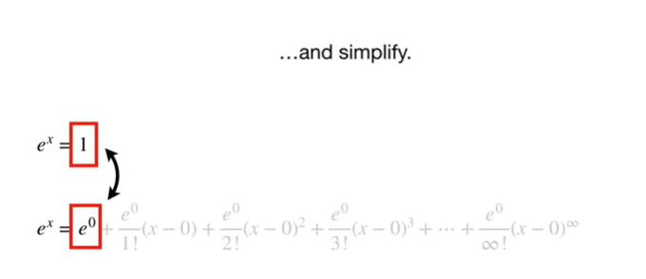

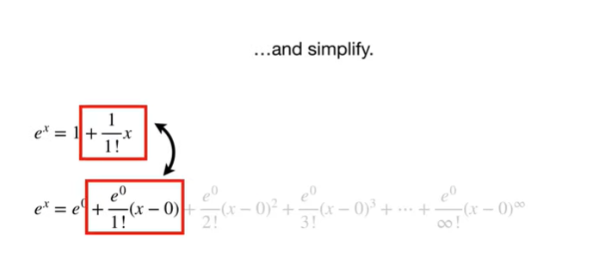

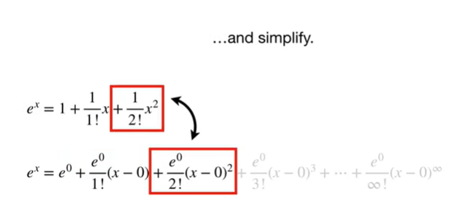

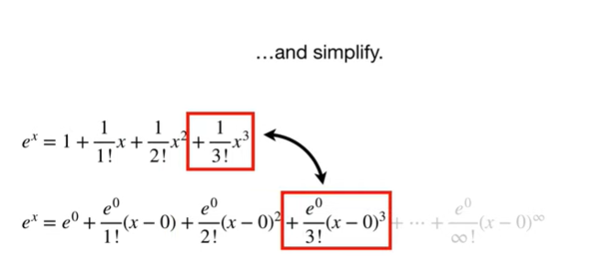

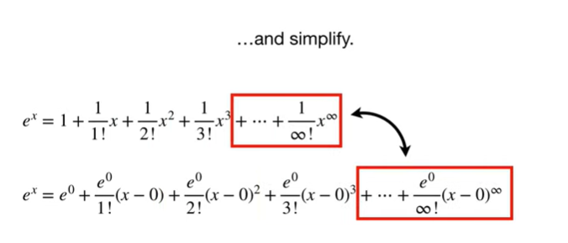

and simplify.

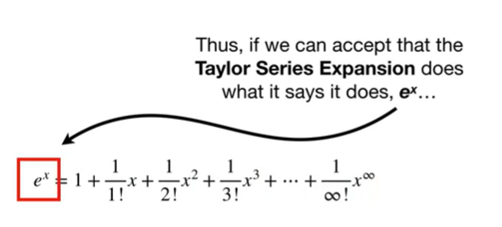

Thus, if we can accept that the Taylor series expansion does what it says it does e to the X

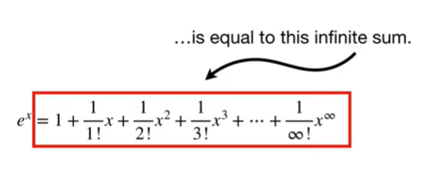

is equal to this infinite sum.

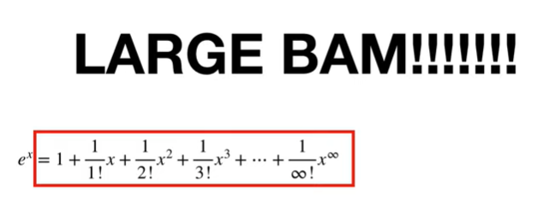

Large BAM !!!!!

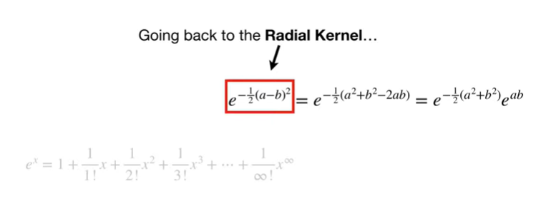

Going back to the radial kernel

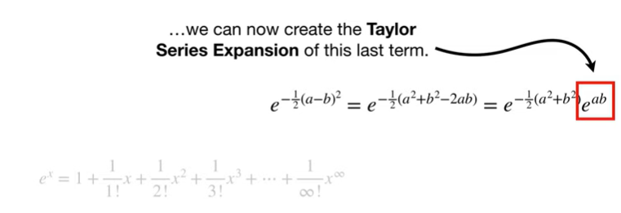

we can now create the Taylor series expansion of this last term.

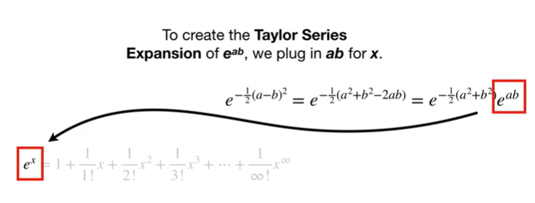

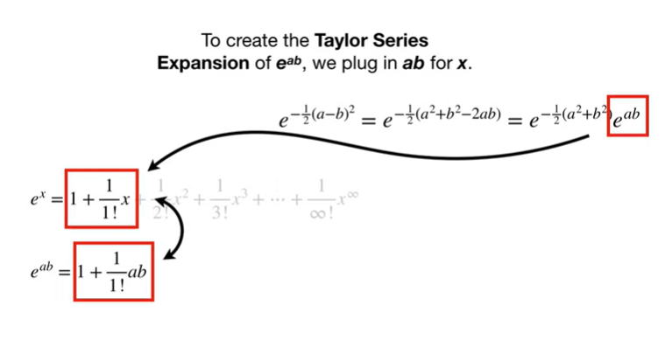

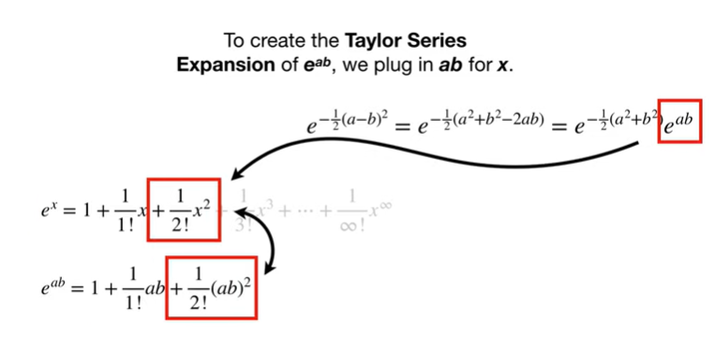

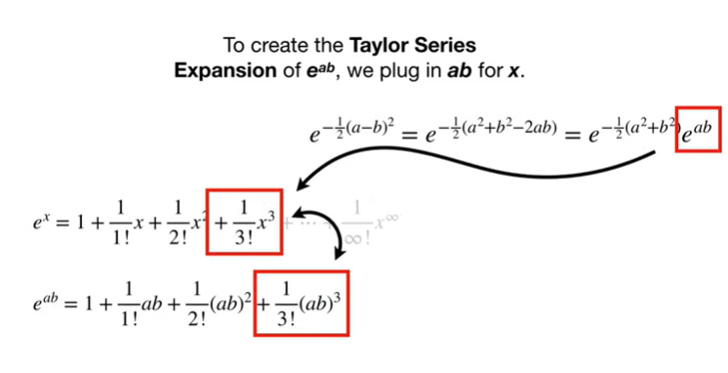

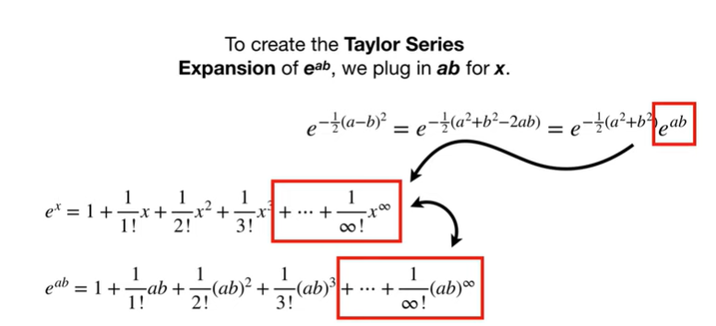

To create the Taylor series expansion of e to the a B we plug in ab for X.

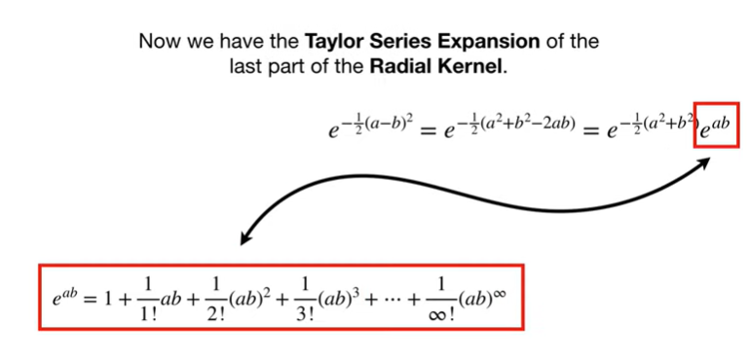

Now we have the Taylor series expansion of the last part of the radial kernel.

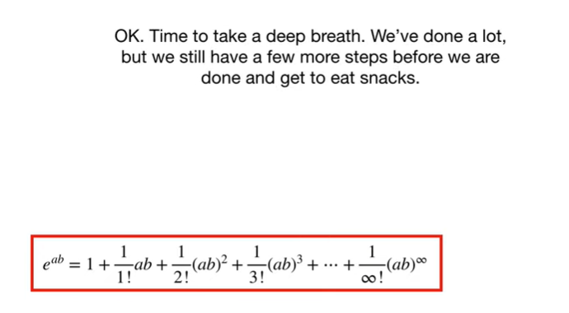

Okay.

Time to take a deep breath.

We've done a lot, but we still have a few more steps before we are done and get to eat snacks.

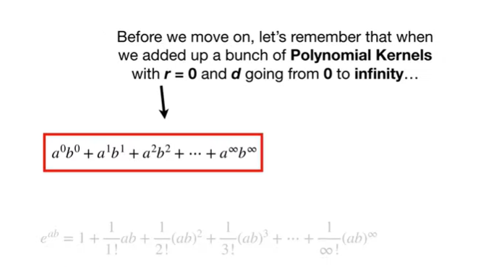

Before we move on, let's remember that when we added up a bunch of polynomial kernels with r equals 0 and d going from 0 to infinity

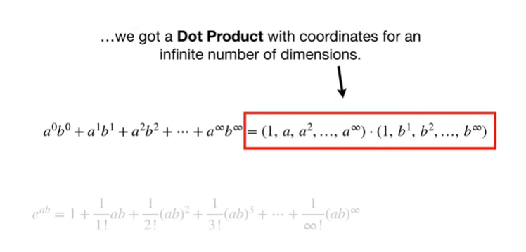

we got a dot product with coordinates for an infinite number of dimensions.

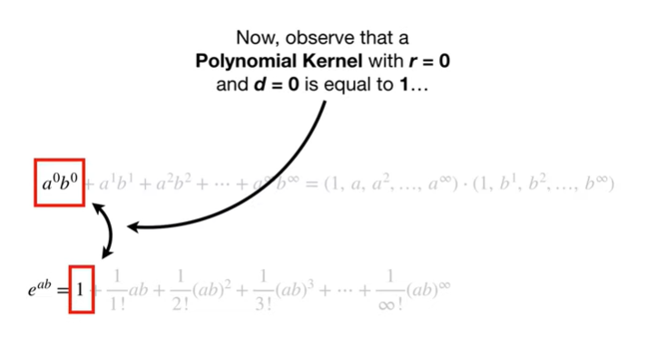

Now observe that a polynomial kernel with R equals 0 and D equals 0 is equal to 1

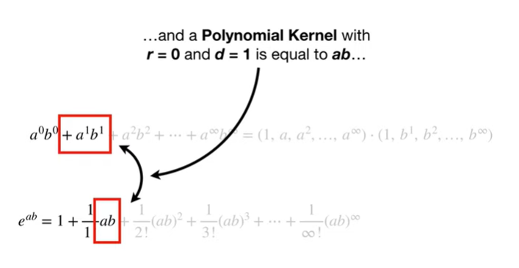

and a polynomial kernel with R equals 0 and D equals 1 is equal to a times B

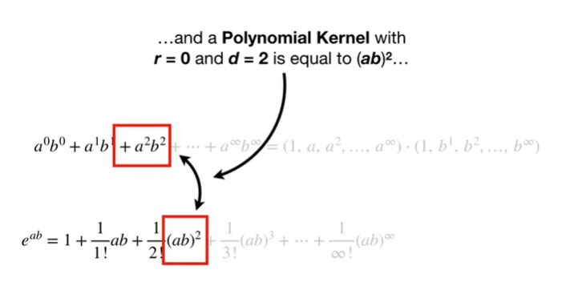

and a polynomial kernel with R equals 0 and D equals to is equal to a times B squared

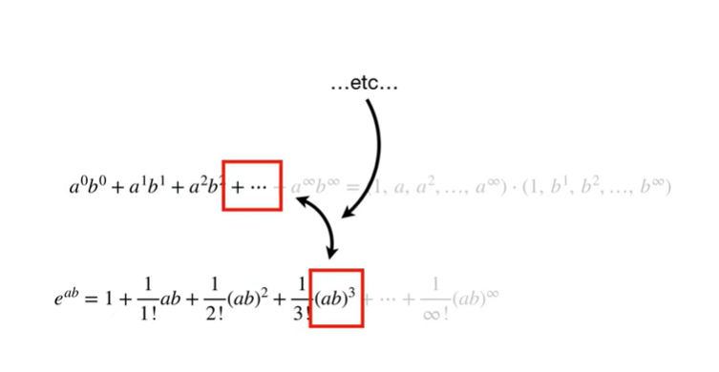

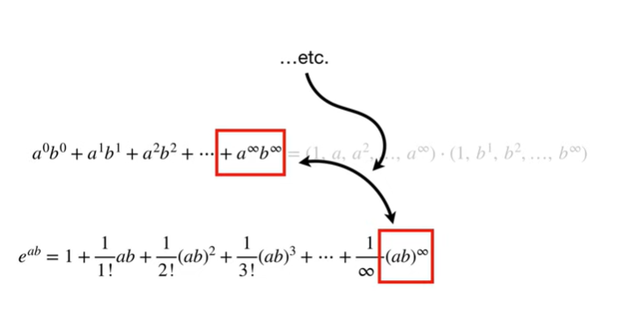

etc etc etc.

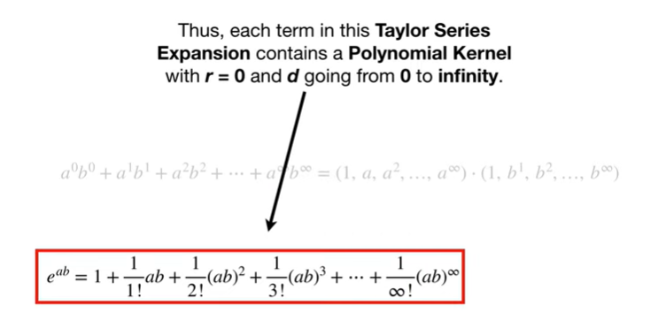

Thus each term in this Taylor series expansion contains a polynomial kernel with R equals 0 and D going from 0 to infinity.

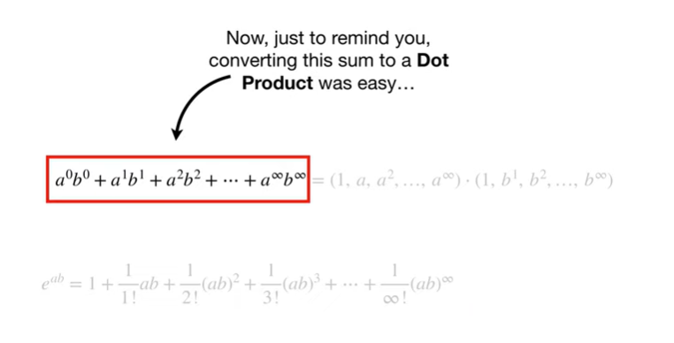

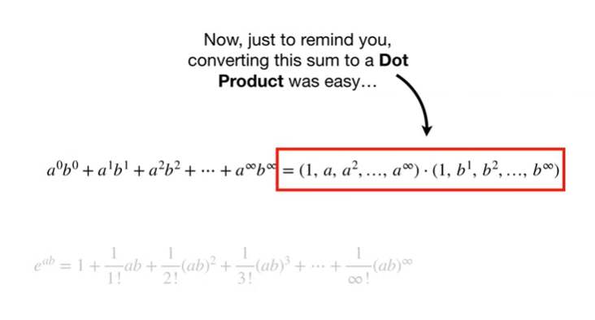

Now, just to remind you, converting this sum to a dot product was easy

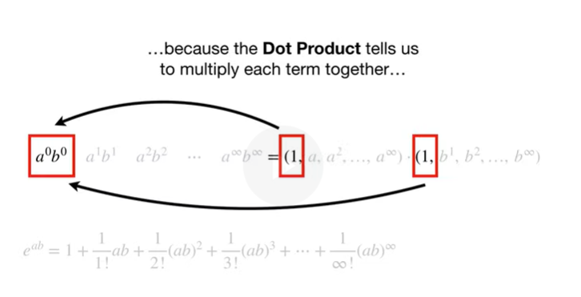

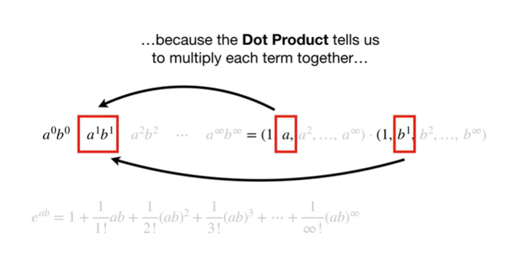

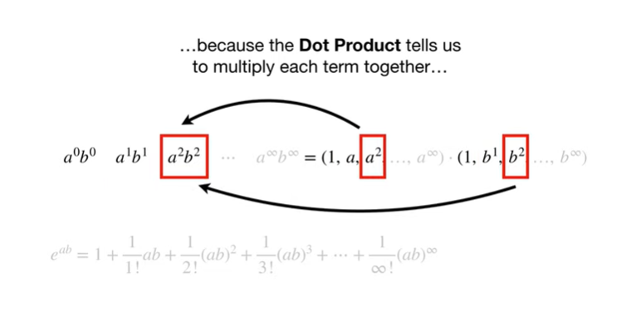

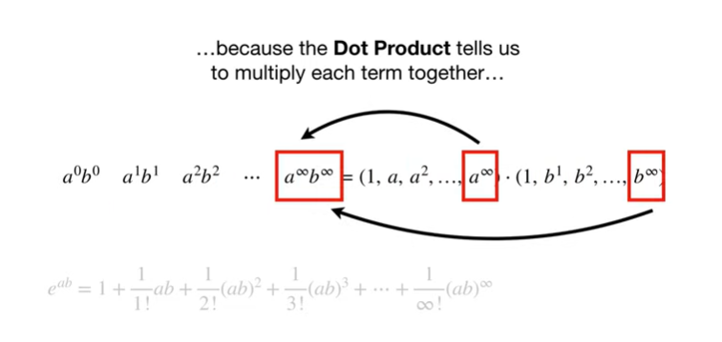

because the dot product tells us to multiply each term together

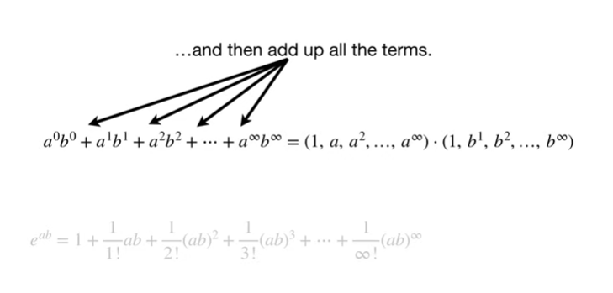

and then add up all the terms.

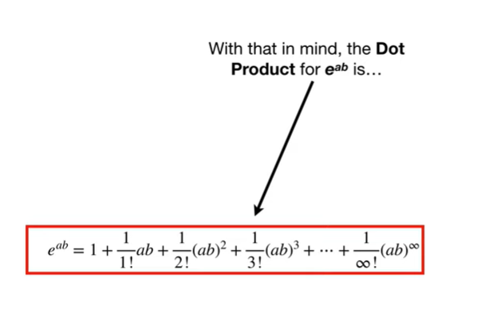

With that in mind the dot product for e to the a B is

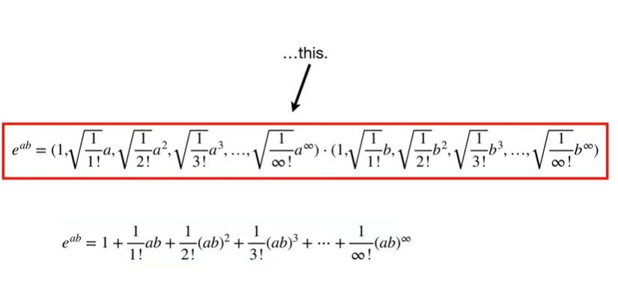

This.

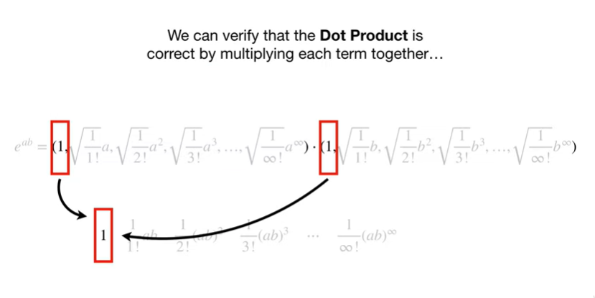

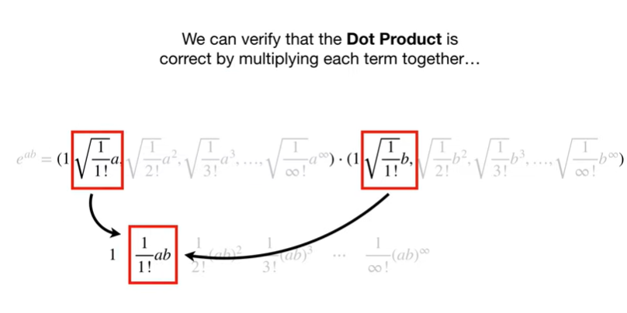

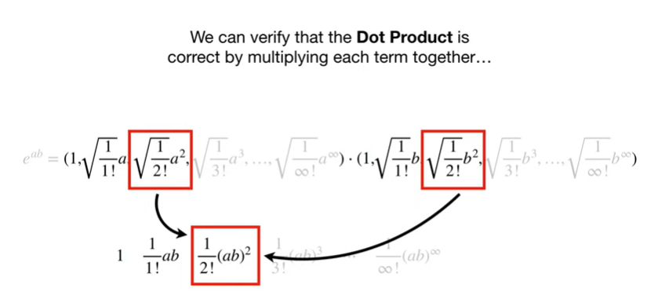

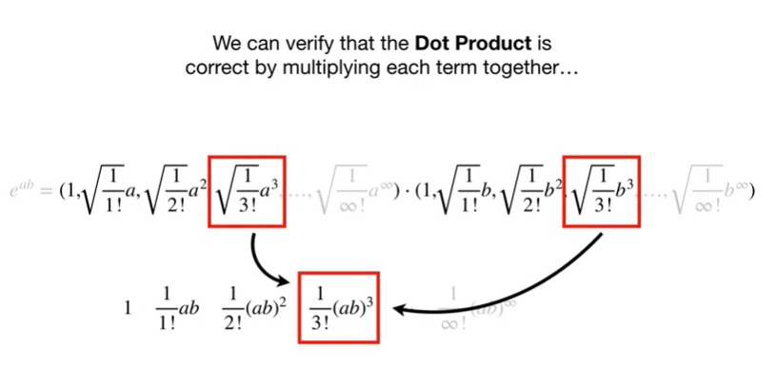

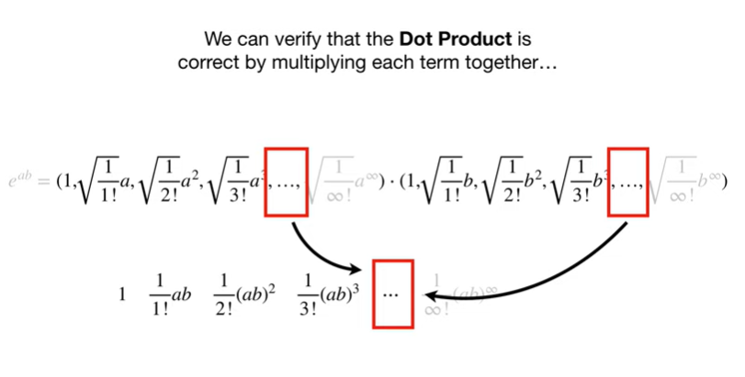

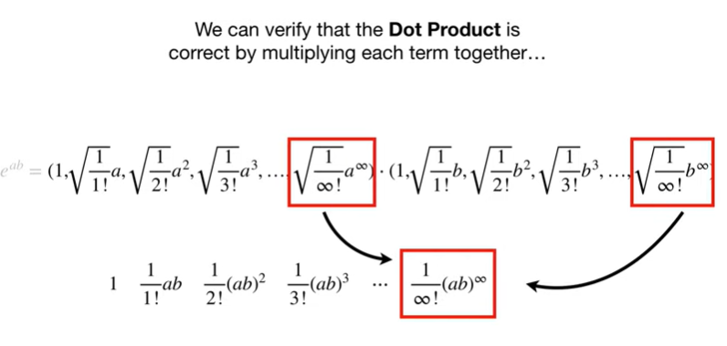

We can verify that the dot product is correct by multiplying each term together

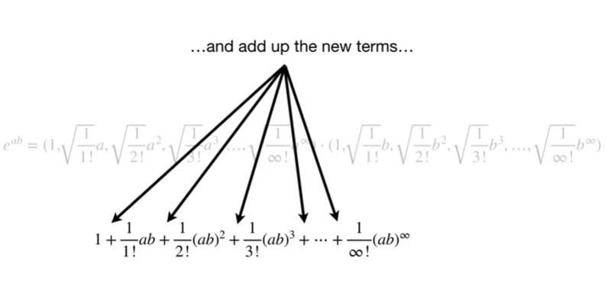

and add up the new terms

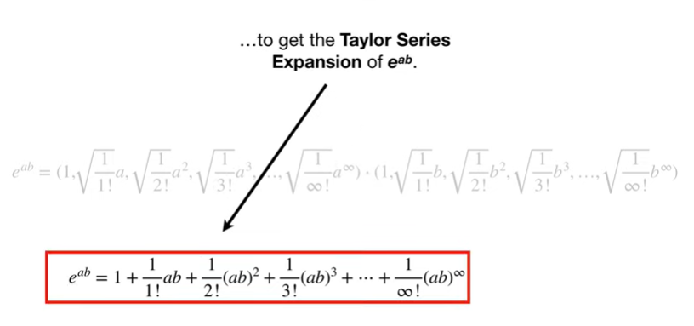

to get the Taylor series expansion of e to the a B.

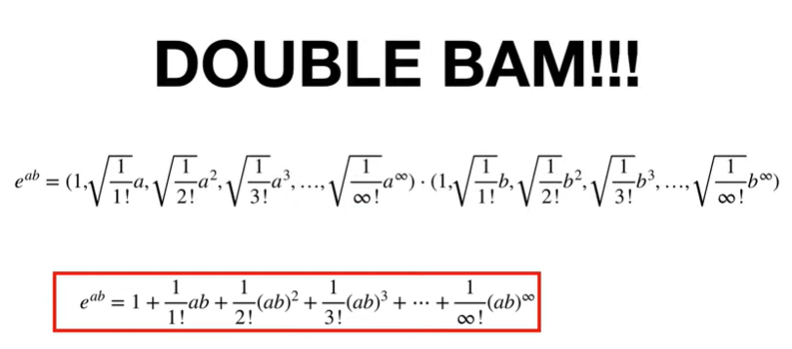

Double bam !!!

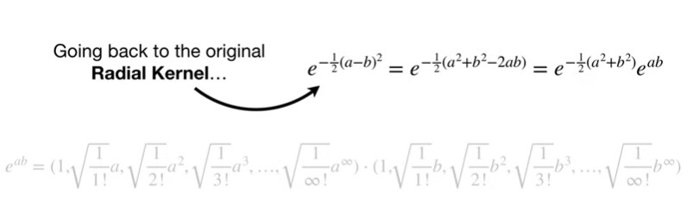

Back to the original radial kernel

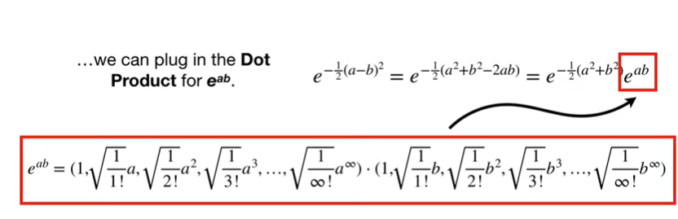

we can plug in the dot product for e to the a B.

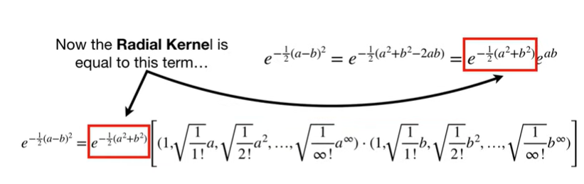

Now the radial kernel is equal to this term

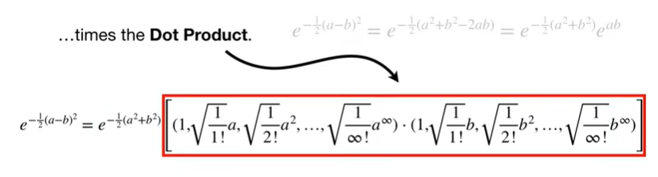

times the dot product.

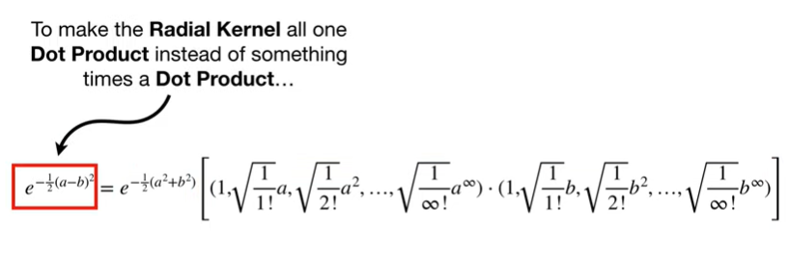

To make the radio Colonel all one dot product

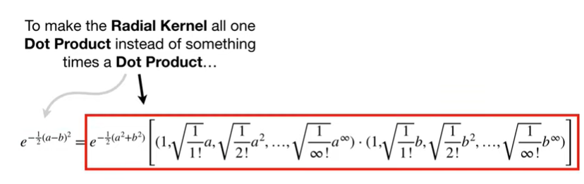

instead of something times a dot product

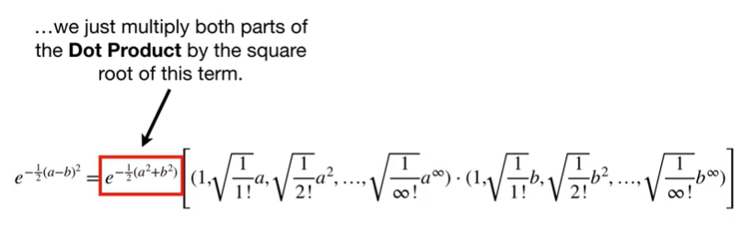

we just multiply both parts of the dot product by the square root of this term.

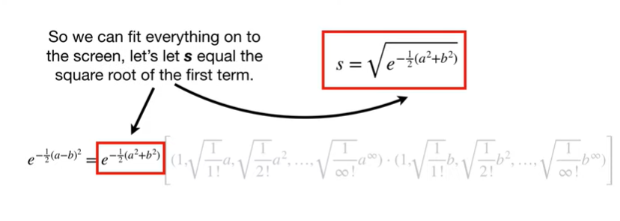

So we can fit everything onto the screen, let's let s equal the square root of the first term.

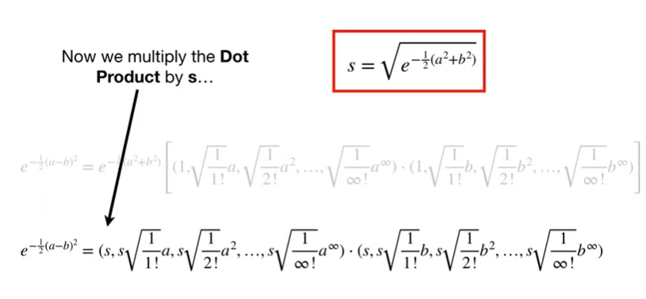

Now we multiply the dot product by

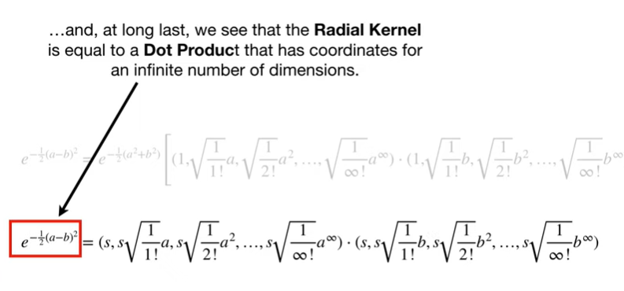

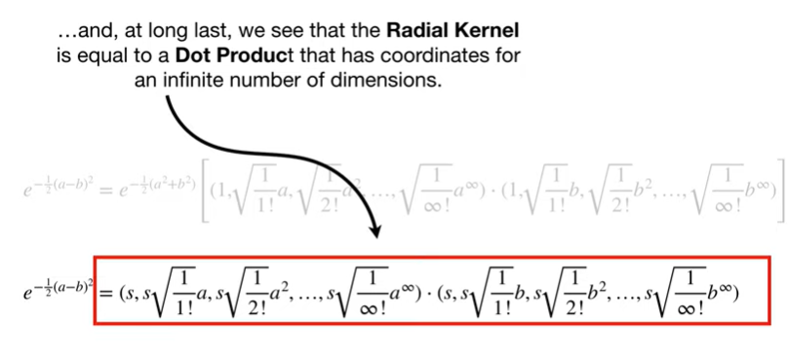

And, at long last, we see that the radial kernel is equal to a dot product that has coordinates for an infinite number of dimensions.

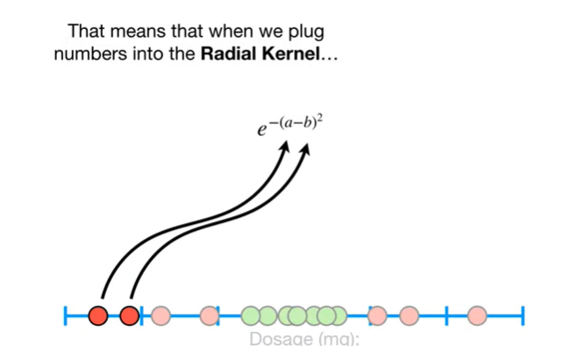

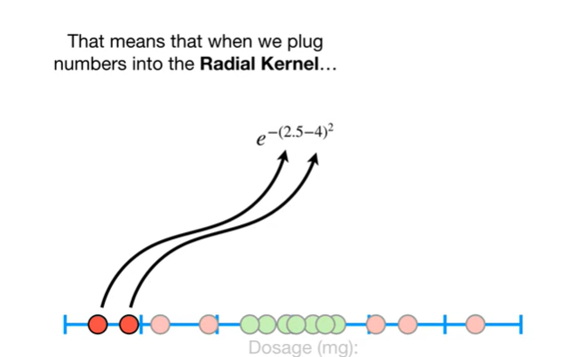

That means when we plug numbers into the radial kernel

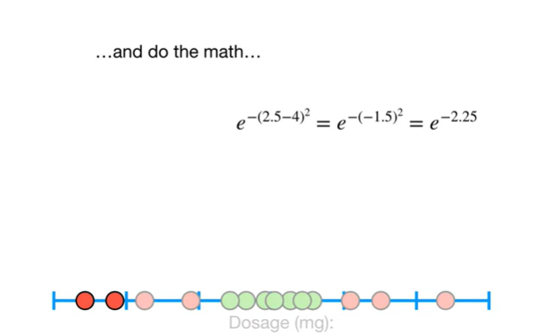

and do the math

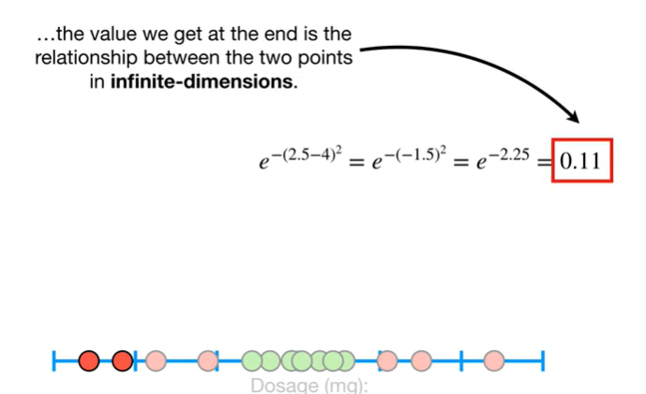

the value we get at the end is the relationship between the two points in infinite dimensions.



Triple bam !!!



Now we can go eat snacks !!!